Here is a template for your reference.



courseware report on

**“Snake Game Player”**

Created by

Name: **云舒** (MD NUR HAMIM)

ID: 2111551204

Class: 21lq

Under The Guidance of

**Dr. Liu Chun**

**(**Assistant professor, Dept. of CST)

**Department of Computer Science & Technology**

**Hubei University of Technology**

**Wuhan, Hubei Province, P. R. China**

**Content**

**CHAPTER PAGE NO.**

**List of Figure i**

**List of Table ii**

**Acknowledgment iii**

**Abstract iv**

**1. INTRODUCTION 1-2**

**1.1 Introduction 1**

**1.2 Objectives 1**

**1.3 Project Description 1**

**2. HARDWARE DESIGN 2-10**

**2.1 Hardware Diagram 2**

2.1.1 The Hardware Diagram consists of 2

**2.2 Circuit Diagram 3**

2.2.1 Components Used in the Circuit 4

2.2.2 Components Description 4

**3. SOFTWARE DESIGN 11-23**

**3.1 Software Diagram 11**

**3.2 Flow Chart 11**

**3.3 Function 12-18**

3.3.1 Draw a robust snake 12

3.3.2 Double linked list 13

3.3.3 Back Insertion 14

3.3.4 Typical D-link list operation 15

3.3.5 Snake move 16

3.3.6 Cross the boundary 16

3.3.7 Food reproduce 16

3.3.8 snake_map[] 17

**3.4 Another method to design software 19-23**

3.4.1 Big point 19

3.4.2 Snake 29

3.4.3 Food 20

3.4.4 Snake move 21

3.4.5 Initial values used in the I/O ports 22

**4. SYSTEM DESIGN 24-27**

**4.1 Complete System Diagram (Hardware) 24**

**4.2 Complete System Diagram (Software) 24**

4.2.1 Game Running 25

4.2.2 Game Over 26

4.2.3 New Game 26

**5. DISCUSSION & REFERENCE 27**

**5.1 Discussions 27**

**5.2 References 27**

**6. CODE 28-83**

**6.1 main.c 28**

**6.2 lcddrv.c 36**

**6.3 target.c 50**

**6.4 Startup.s 57**

**6.5 config.h 63**

**6.6 lcddrv.h 67**

**6.7 LPC2124.h 68**

**6.8 target.h 81**

**6.9 LPC2124.sct 83**

**List of Figure**

**FIGURE PAGE NO.**

**Figure 1: Hardware Diagram 2**

**Figure 2: Circuit Diagram 3**

**Figure 3: LPC2124 4**

**Figure 4: Pin Diagram of LPC 2124 5**

**Figure 5: LM3228 LCD 7**

**Figure 6: 4X4 KEYPAD 8**

**Figure 7: KEYPAD PINOUT 9**

**Figure 8: 10K Resistor 10**

**Figure 9: Software Diagram 11**

**Figure 10: Flowchart 11**

**Figure 11: Nine small cells 12**

**Figure 12: Doubly Linked List Node 13**

**Figure 13: Back insertion 14**

**Figure 14: Complete System Diagram (Hardware) 24**

**Figure 15: Complete System Diagram (Software) 24**

**Figure 16: Game running-1 25**

**Figure 17: Game running-2 25**

**Figure 18: Game over 26**

**Figure 19: New game 26**

**TABLE PAGE NO.**

**Table 1: Components Used in the Circuit 3**

**Table 2: PINSEL Table 6**

**Table 3: LM3228 LCD Pin Description 8**

**Table 4: Description of KEYPAD Pin 9**

**Acknowledgment**

We offer appreciation to project manager Asst. Prof. Dr. Liu Chun (Dept. Of Computer Science and Technology, HBUT) for directing us all through the task, the work and giving us addresses and making sense of the undertaking and aiding when we were stops in the center during the advancement stage. We could never have constructed such a difficult task without his assistance.

**Abstract**

This undertaking intends to bring the tomfoolery and effortlessness of snake game for certain new highlights. It will incorporate PC controlled canny rivals whose point will be to challenge the human players. It will likewise have the multiplayer highlight that will permit more than one players to play the game over an organization.

This undertaking investigates another aspect in the conventional snake game to make it really fascinating and testing. The effortlessness of this game creates it an ideal possibility for a minor undertaking as we can zero in on cutting edge subjects like multiplayer usefulness and execution of PC controlled shrewd rivals.

**Chapter 1**

**1.1 Introduction**

Project documentation is concerned with describing the delivered software product, in this case the Snake game project. Project documentation includes user documentation which tells users how to use the software product and system documentation which is principally intended for further development and understanding.

**1.2 Objectives**

Snake game is a mobile action game, whose goal is to control a snake to move and collect food in a map. In this paper we develop a controller based on movement rating functions considering smoothness, space, and food. Scores given by these functions are aggregated by linear weighted sum, and the snake takes the action that leads to the highest score. To find a set of good weight values, we apply an evolutionary algorithm. We examine several algorithm variants of different crossover and environmental selection operators. Experimental results show that our design method is able to generate smart controllers.

**1.3 Project Description**

Snake Game project is a mobile game application. This game is created for the recreation of people. To create this game we actually need some hardware device and software application. For hardware we mainly need micro-controller, LCD and Keypad. Now how this game may played.

Firstly Welcome screen,

This is the starting screen in your game, on pressing s should start the game. On this screen, you have to provide an overview of the scoring system and the controls.

Secondly Moving the Player

Currently, the snake doesn't move at all. Let's make it move. To Do:

• The snake should move up, down, left, and right when you press those arrows.

• The snake shouldn't have a sudden change in direction. It should not move left immediately if it is moving right or vice versa. Same is true for up and down movements i.e., if the snake is going up and the down arrow is pressed, nothing should happen. That is supposed to be true for every opposite direction The enumeration for UP, DOWN, LEFT and RIGHT are defined in (key.h). Snake should eat the food

If you get the snake moving, you will see that it just walk (slithers) over the food right now. To Do:

• Make it eat the food.

• It should grow by size if it eats a growing food and should reduce in size if it eats a reducing (junk) food. These food are indicated by 'X' and 'O' on the board.

• Once eaten, the food should disappear and another food (of random type) should be spawn at a random location on the game window.

Show points

No points are printed right now. To Do:

• Calculate the points as per the food eaten*

**2. HARDWARE DESIGN**

**2.1 Hardware Diagram**

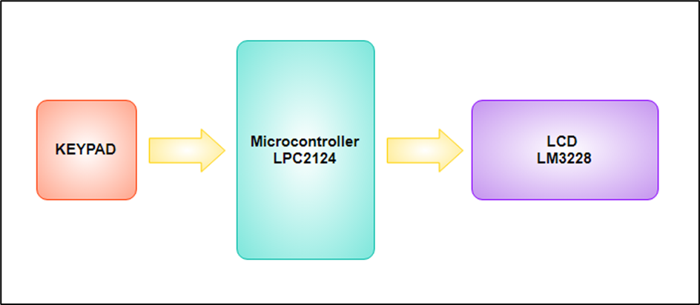

**Figure 1: Hardware Diagram**

**2.1.1 The Hardware Diagram consists of**

1. **Microcontroller LPC2124**
2. **LCD LM3228**
3. **KEYPAD**

**2.2 Circuit Diagram**

**2.2.1 Components Used in the Circuit**

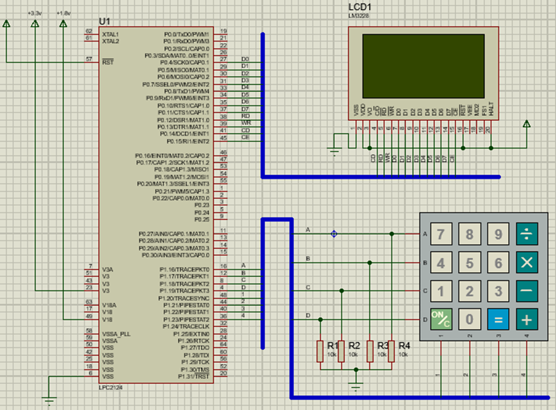

**Figure 2: Circuit Diagram**

**2.2.2 Components Description**

|  |  |  |
| --- | --- | --- |
| **SL. No.** | **Components** | **Specification** |
| 1 | Microcontroller | LPC2124 |
| 2 | LCD | LM3228 |
| 3 | KEYPAD | SMALLCALC |
| 4 | Resistors | 10K |

**Microcontroller**

In this project we’re using the NXP (founded by Philips) LPC2124 Microcontroller. The NXP LPC2124 is an ARM7TDMI-S based high-performance 32-bit RISC Microcontroller with Thumb extensions 256KB on-chip Flash ROM with In-System Programming (ISP) and In-Application Programming (IAP) 16KB RAM, Vectored Interrupt Controller, Two UARTs, I2C serial interface, 2 SPI serial interfaces, Two timers (7 capture/compare channels), PWM unit with up to 6 PWM outputs, 4-channels 10bit ADC, Real Time Clock, Watchdog Timer, General purpose I/O pins. CPU clock up to 60 MHz, On-chip crystal oscillator and On-chip PLL.



**Figure 3: LPC2124**

**Basics of LPC2124**

When coming to ARM7 Programming there are 5 things you need to be get familiarize with. They are-

* PINSEL
* IODIR
* IOSET
* IOCLR
* IOPIN



**Figure 4: Pin Diagram of LPC 2124**

**PINSEL:**

A 32 bit register which is used to select the function of the pins in which the user needs it to operate. There are four functions for each pins of the controller, in which the first function one was GPIO (General Purpose Input Output). It means that the pin can either act as an Input or Output with no specific functions

.There are totally three PINSEL register in LPC2124 Controller in order to control the functions of the Pins in the respective ports. The classification is given below

PINSEL0 – Controls functions of Port0.0 – Port0.15

PINSEL1 – Controls functions of Port0.16-Port0.31

PINSEL2 – Controls functions of Port1.16-Port1.31

|  |  |  |  |  |  |  |
| --- | --- | --- | --- | --- | --- | --- |
| **Pin Name** | **Function when 00** | **PINSEL0** | **Function when 01** | **Function when 10** | **Function when 11** | **Reset Value** |
| P0.0 | GPIO Port 0.0 | 1:0 | TxD (UART0) | PWM1 | Reserved | 00 |
| P0.1 | GPIO Port 0.1 | 3:2 | RxD (UART0) | PWM3 | EINT0 | 00 |
| P0.2 | GPIO Port 0.2 | 5:4 | SCL (I2C) | Capture 0.0 (TIMER0) | Reserved | 00 |
| P0.3 | GPIO Port 0.3 | 7:6 | SDL (I2C) | Match 0.0 (TIMER0) | EINT1 | 00 |
| P0.4 | GPIO Port 0.4 | 9:8 | SCK (SPI0) | Capture 0.1 (TIMER0) | Reserved | 00 |
| P0.5 | GPIO Port 0.5 | 11:10 | MISO (SPI0) | Match 0.1 (TIMER0) | Reserved | 00 |
| P0.6 | GPIO Port 0.6 | 13:12 | MOSI (SPI0) | Capture 0.2 (TIMER0) | Reserved | 00 |
| P0.7 | GPIO Port 0.7 | 15:14 | SSEL (SPI0) | PWM2 | EINT2 | 00 |
| P0.8 | GPIO Port 0.8 | 17:16 | TxD (UART1) | PWM4 | Reserved | 00 |
| P0.9 | GPIO Port 0.9 | 19:18 | RxD (UART1) | PWM6 | EINT3 | 00 |
| P0.10 | GPIO Port 0.10 | 21:20 | RTS (UART1) | Capture 1.0 (TIMER1) | Reserved | 00 |
| P0.11 | GPIO Port 0.11 | 23:22 | CTS (UART1) | Capture 1.1 (TIMER1) | Reserved | 00 |
| P0.12 | GPIO Port 0.12 | 25:24 | DSR (UART1) | Match 1.0 (TIMER1) | Reserved | 00 |
| P0.13 | GPIO Port 0.13 | 27:26 | DTR (UART1) | Match 1.1 (TIMER1) | Reserved | 00 |
| P0.14 | GPIO Port 0.14 | 29:28 | CD (UART1) | EINT1 | Reserved | 00 |
| P0.15 | GPIO Port 0.15 | 31:30 | RI (UART1) | EINT2 | Reserved | 00 |

**Table 2: PINSEL Table**

**IODIR:**

Like DDR in AVR and TRIS in PIC, ARM uses IODIR register to specify the direction which in which we are going to use the pins. Two 32 bit registers IODIR0 for Port0 (P0.0 – P0.31) and IODIR1 for Port (P1.16- P1.31). Kindly note that loading values in IODIR, it will take effect only if the Pins are used as GPIO and the directions are controlled automatically if it was specified with any special functions

**IOSET:**

This Register is meant to set the pins in the Ports where writing 1 to it will set the respective pin while 0 will have no effect. There are two registers dedicated for both the ports IOSET0 –P0.0 – P0.31 and IOSET1 for P1.16 – P1.31

**IOCLR:**

This Register is meant to clear the pins in the Ports where writing 1 will clear the respective pin while 0 will have no effect in the Ports. There are two registers dedicated for both the ports IOCLR0 –P0.0 – P0.31 and IOCLR1 for P1.16 – P1.31

**IOPIN:**

This is used only when we assign certain pins as Input in the IODIR register. There are two registers dedicated for both the ports IOPIN0 –P0.0 – P0.31 and IOPIN1 for P1.16 – P1.

**2. LCD2**

In this project we’re using LM3228 LCD (Liquid Crystal Display). It’s a 128 x 64 Dots Graphic LCD. It has 20 pin to control whole things.

**FEATURES**

• 128 x 64 dots + 4 Icons

• Built-in controller (KS0108)

• + 5V power supply

• 1/64 duty cycle

• EL backlight (built-in EL inverter)

• Built-in N.V



**Figure 5: LM3228 LCD**

|  |  |  |
| --- | --- | --- |
| **PIN NUMBER** | **SYMBOL** | **FUNCTION** |
| 1 | VSS | Ground (0V) |
| 2 | VDD | Logic Supply Voltage (+5V) |
| 3 | VO | LCD drive voltage for contrast adjustment |
| 4 | C/D | WR=“L”...C/D=“H” : Command write C/D=“L”: Data write  RD=“L”...C/D=“H” : Status read C/D=“L”: Data read |
| 5 | RD | Data read Active Low |
| 6 | WR | Data write Active Low |
| 7 | D0 | Data Bus Line 0 |
| 8 | D1 | Data Bus Line 1 |
| 9 | D2 | Data Bus Line 2 |
| 10 | D3 | Data Bus Line 3 |
| 11 | D4 | Data Bus Line 4 |
| 12 | D5 | Data Bus Line 5 |
| 13 | D6 | Data Bus Line 6 |
| 14 | D7 | Data Bus Line 7 |
| 15 | CE | Chip enable Active Low |
| 16 | RST | Chip reset Active Low |
| 17 | VEE | Negative voltage input for LC drive (Negative voltage output for  models with on-board negative voltage generator) |
| 18 | MD2 | Mode Selection |
| 19 | FS1 | Terminals for selection of font size |
| 20 | HALT | Halt Function (H = Normal, L = Stop Oscillation) |

**Table 3: LM3228 LCD Pin Description**

**3. KEYPAD**

We’re using **4X4 KEYPAD in this project**



**Figure 6: 4X4 KEYPAD**

**4X4 KEYPAD Pin Configuration**

4X4 KEYPAD MODULES are available in different sizes and shapes. But they all have same pin configuration. It is easy to make 4X4 KEYPAD by arranging 16 buttons in matrix formation by yourself.



**Figure 7: KEYPAD PINOUT**

|  |  |
| --- | --- |
| **Pin Number** | **Description** |
| 1 | PIN1 is taken out from 1st ROW |
| 2 | PIN1 is taken out from 2nd ROW |
| 3 | PIN1 is taken out from 3rd ROW |
| 4 | PIN1 is taken out from 4th ROW |
| 5 | PIN1 is taken out from 1st COLUMN |
| 6 | PIN1 is taken out from 2nd COLUMN |
| 7 | PIN1 is taken out from 3rd COLUMN |
| 8 | PIN1 is taken out from 4th COLUMN |

**Table 4: Description of KEYPAD Pin**

**10K Resistor**

A resistor is a passive two-terminal electrical component that implements electrical resistance as a circuit element. In electronic circuits, resistors are used to reduce current flow, adjust signal levels, to divide voltages, bias active elements, and terminate transmission lines, among other uses. Here we using 10K resistor



**Figure 8: 10K Resistor**

**Output images:**

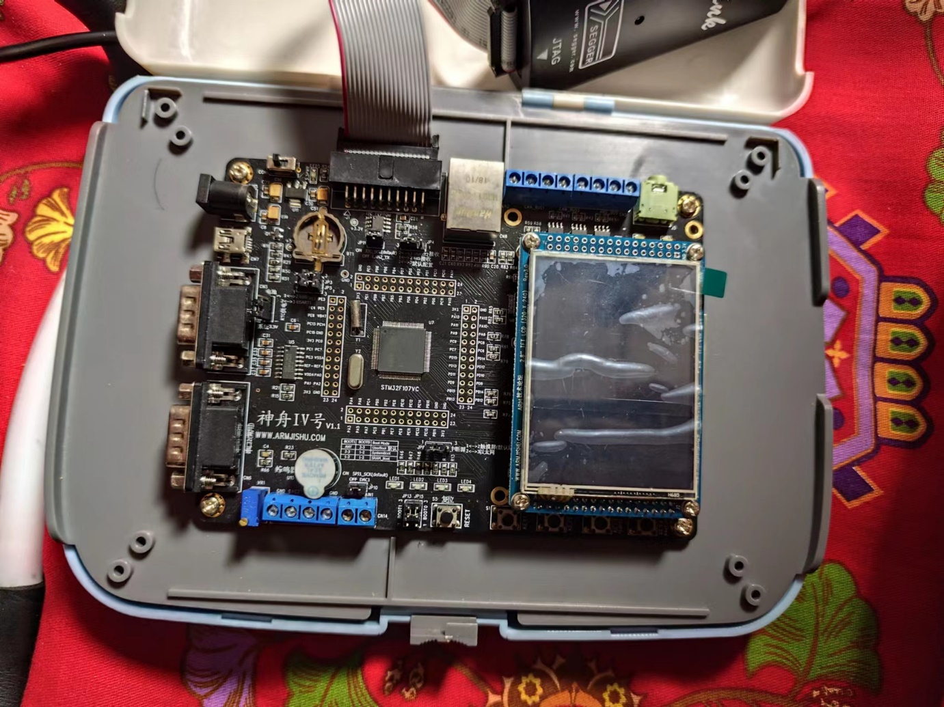

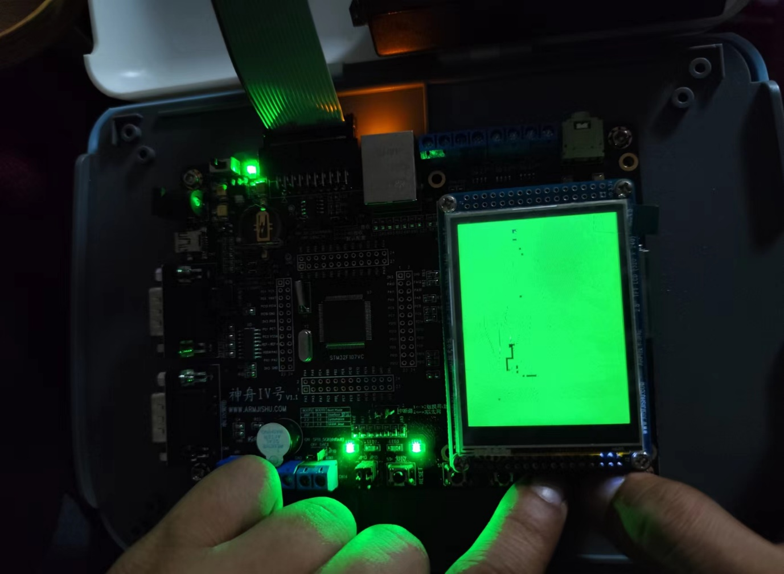

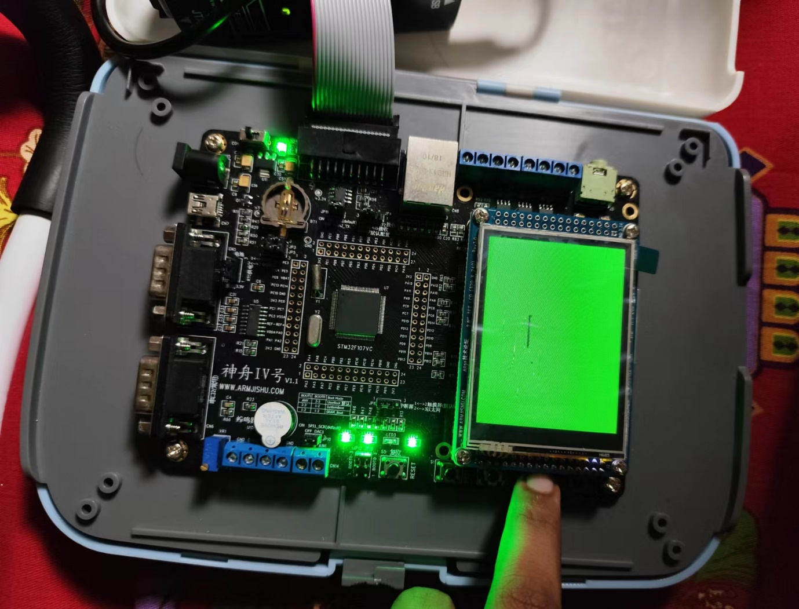

**3. SOFTWARE DESIGN**

**3.1 Software Diagram**

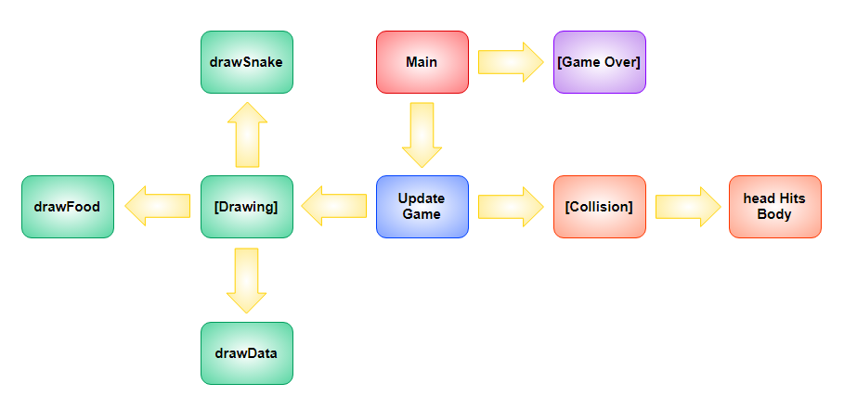

**Figure 9: Software Diagram**

**3.2 Flow Chart**

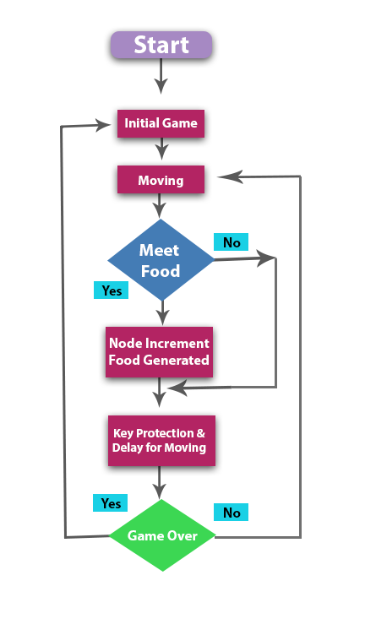

**Figure 10: Flowchart**

**3.3 Function**

**3.3.1 Draw a robust snake**

**. nine small cells**

**.We should draw a robust snake instead of just one point**

**void Display(uint8 x,uint8 y)**

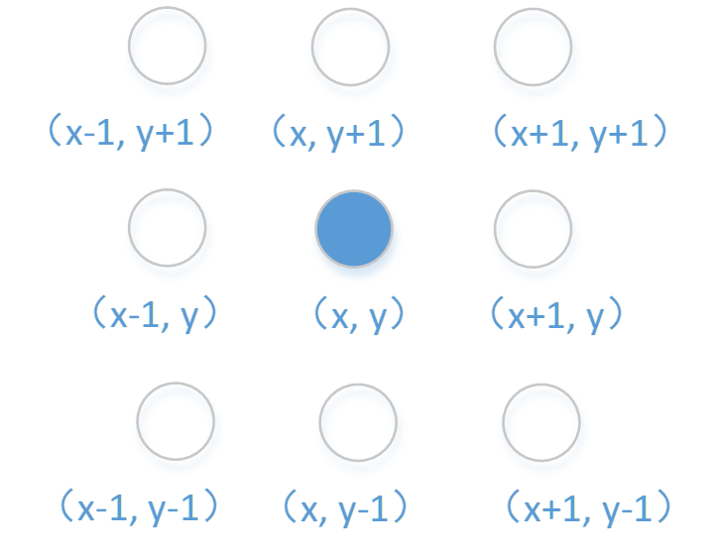

**Figure 11: Nine small cells**

{

GUI_Point(x, y, LCD_DISP_COLOR);

GUI_Point(x+1, y, LCD_DISP_COLOR);

GUI_Point(x-1, y, LCD_DISP_COLOR);

GUI_Point(x, y+1, LCD_DISP_COLOR);

GUI_Point(x, y-1, LCD_DISP_COLOR);

GUI_Point(x+1, y+1, LCD_DISP_COLOR);

GUI_Point(x+1, y-1, LCD_DISP_COLOR);

GUI_Point(x-1, y+1, LCD_DISP_COLOR);

GUI_Point(x-1, y-1, LCD_DISP_COLOR);

}

void Clear(uint8 x,uint8 y)

{

GUI_Point(x, y, LCD_BACK_COLOR);

GUI_Point(x+1, y, LCD_BACK_COLOR);

GUI_Point(x-1, y, LCD_BACK_COLOR);

GUI_Point(x, y+1, LCD_BACK_COLOR);

GUI_Point(x, y-1, LCD_BACK_COLOR);

GUI_Point(x+1, y+1, LCD_BACK_COLOR);

GUI_Point(x+1, y-1, LCD_BACK_COLOR);

GUI_Point(x-1, y+1, LCD_BACK_COLOR);

GUI_Point(x-1, y-1, LCD_BACK_COLOR);

}

**3.3.2 Double linked list**

struct part

{

uint8 x, y;

struct part *next,*per;

};

head_x=21;head_y=10;

struct part *head,*tail;

uint8 snake_map[42][21];

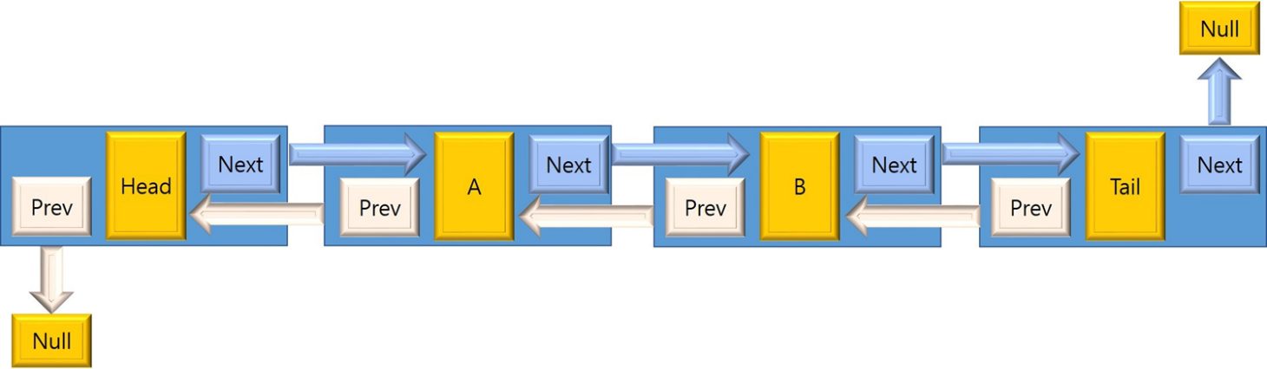

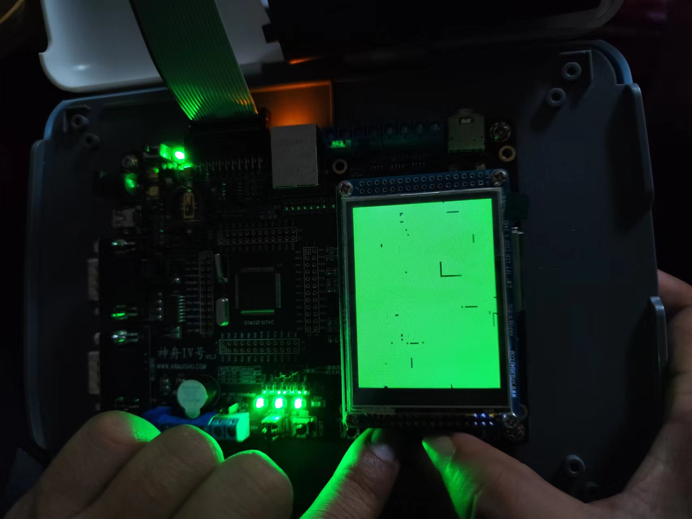

**Figure 12: Doubly Linked List Node**

**3.3.3 The back insertion mirrors the front insertion.**

**The back insertion mirrors the front insertion.**

1. **Create new node (C).**
2. **Check if list is empty.**
   * **If head is empty**
     1. **set C as the new head. Existence of head node indicates that there are elements in the list (well, at least for this implementation).**
   * **Otherwise, check if tail is null.**
     1. **If tail is null**
        1. **Set next node pointer of current head (B) to point to new node (C).**
        2. **Set prev node pointer of new node (C) to point at current head (B).**
     2. **Otherwise,**
        1. **Set the prev node of C to point at current tail (B).**
        2. **Set the next node of B to point at new node (C).**
   * **Assign the newly created node (C) as the new tail.**
   * **Set next node** of **C** **to null.**

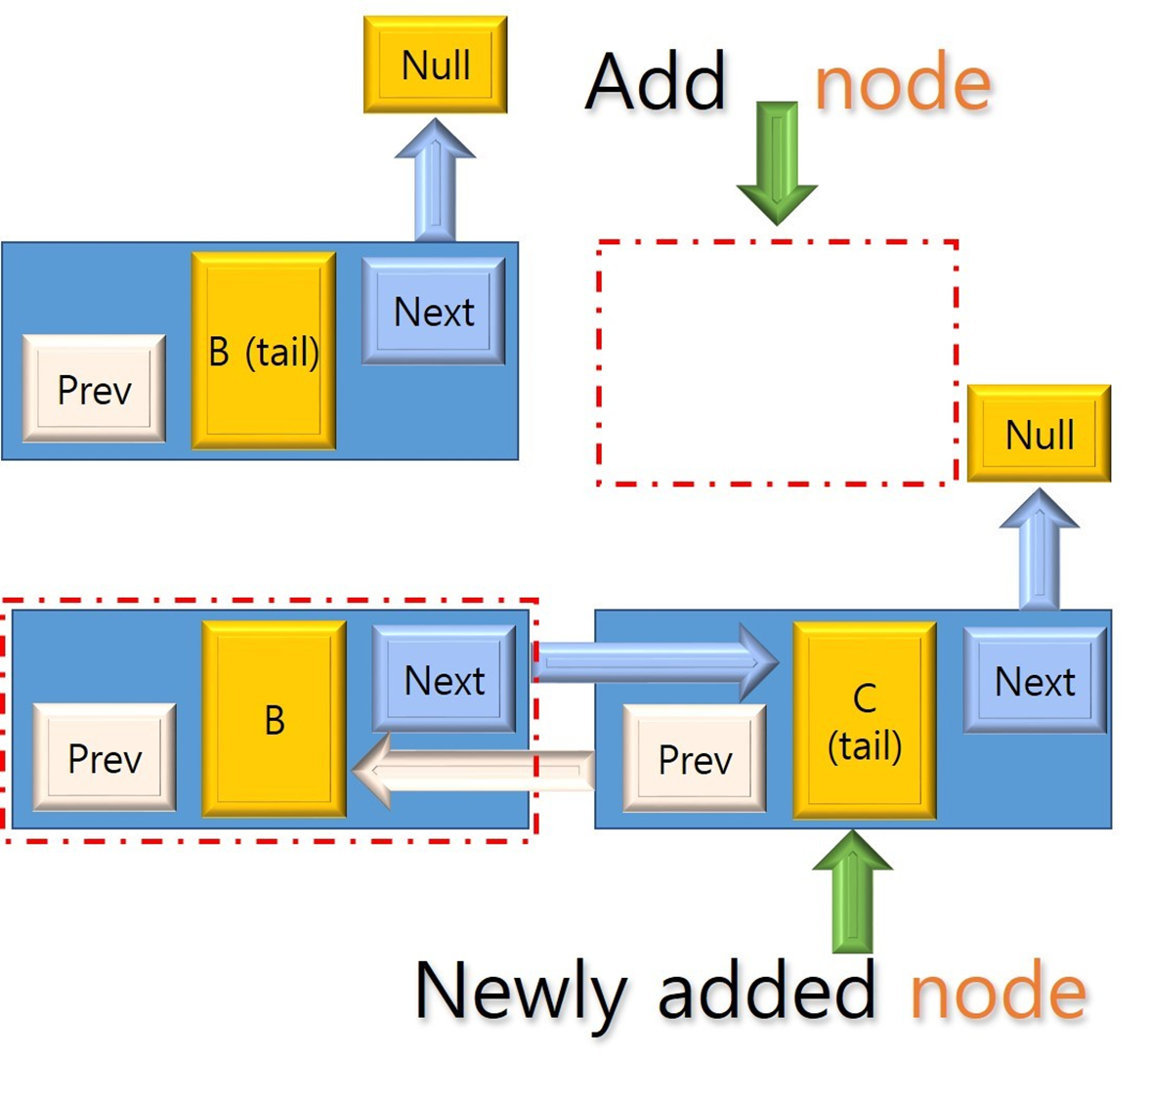

**Figure 13: Back insertion**

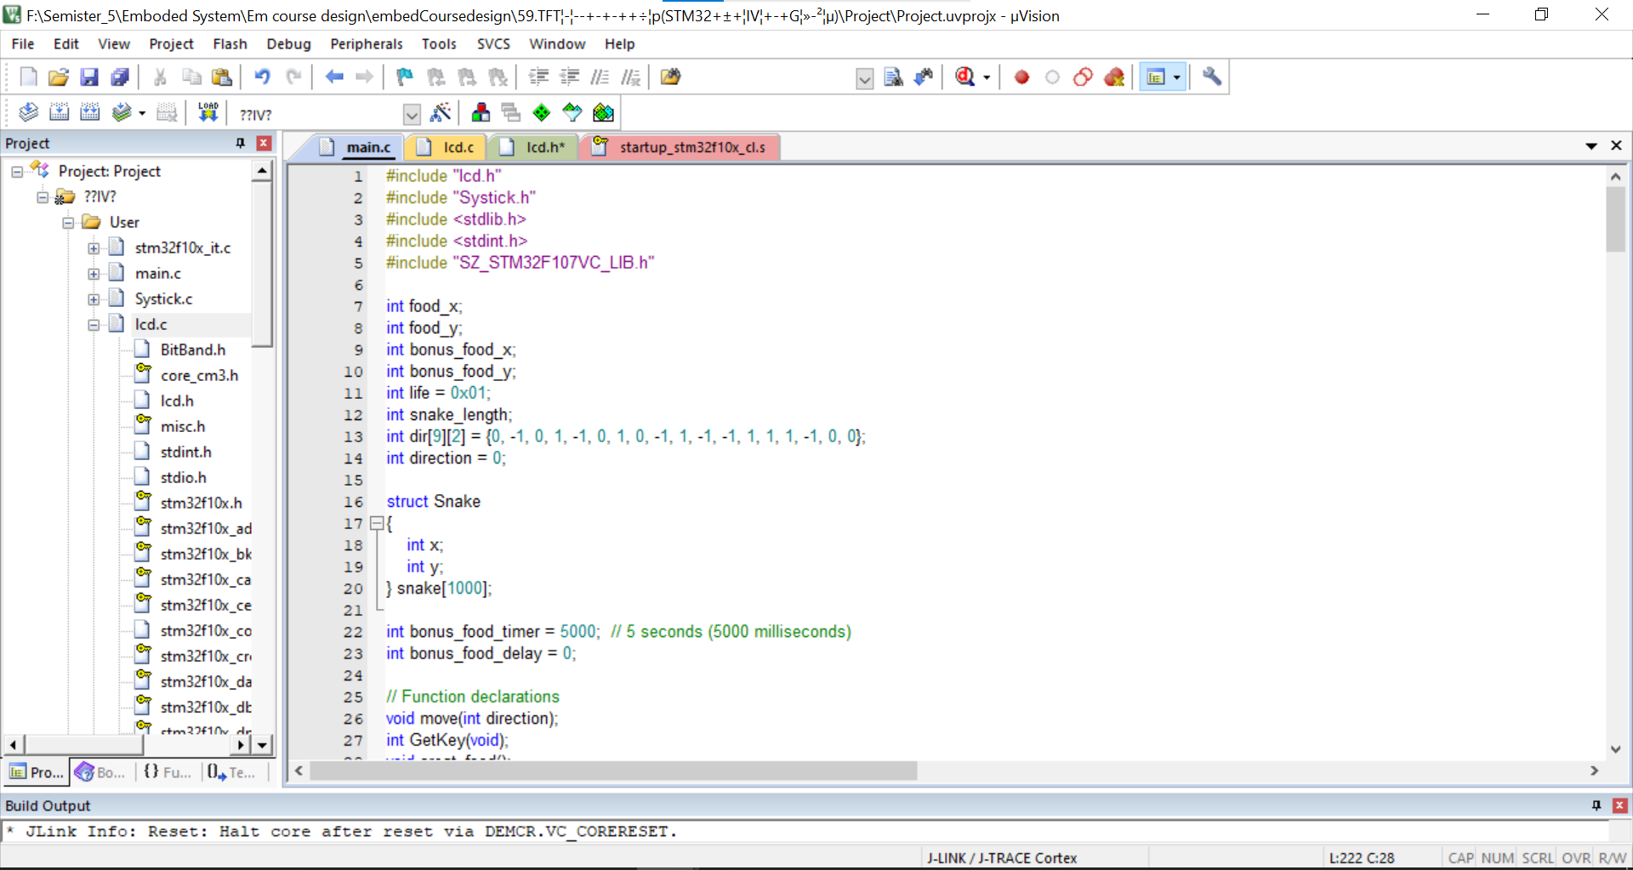



**3.3.1 Header and Libraries**

#include "lcd.h"

#include "Systick.h"

#include <stdlib.h>

#include <stdint.h>

#include "SZ_STM32F107VC_LIB.h"

**3.3.2 Struct Snake**

struct Snake {

int x;

int y;

}

snake[1000];

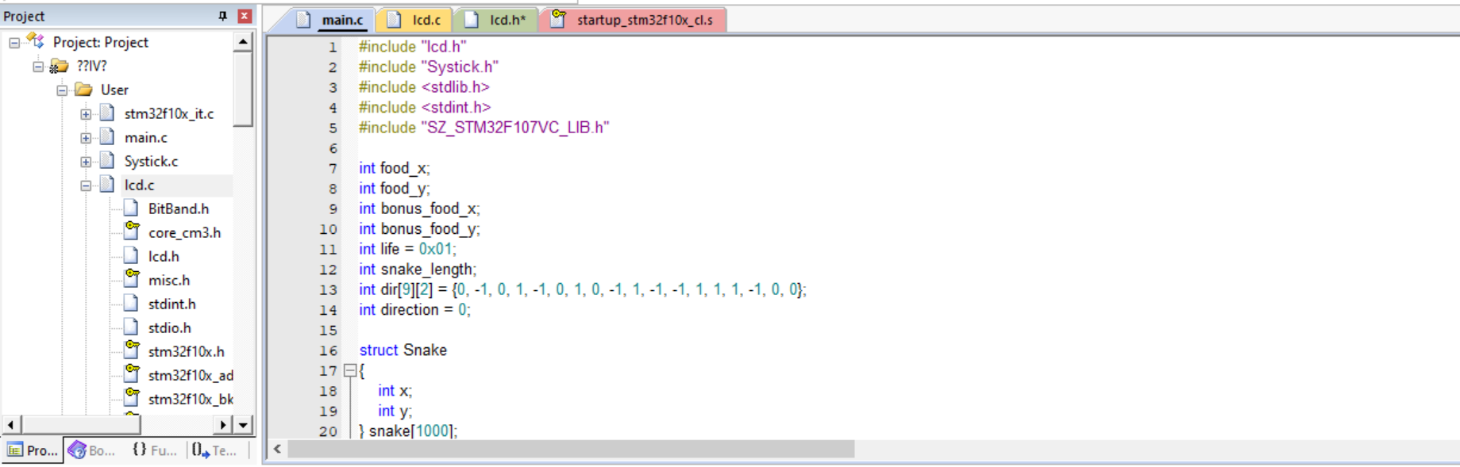

**3.3.3 Function Declarations**

void move(int direction);

int GetKey(void);

void creat_food();

void creat_bonus_food();

void snake_init(int x, int y);

void Big_Point(int x, int y, int color);

**3.3.4 Main Function**

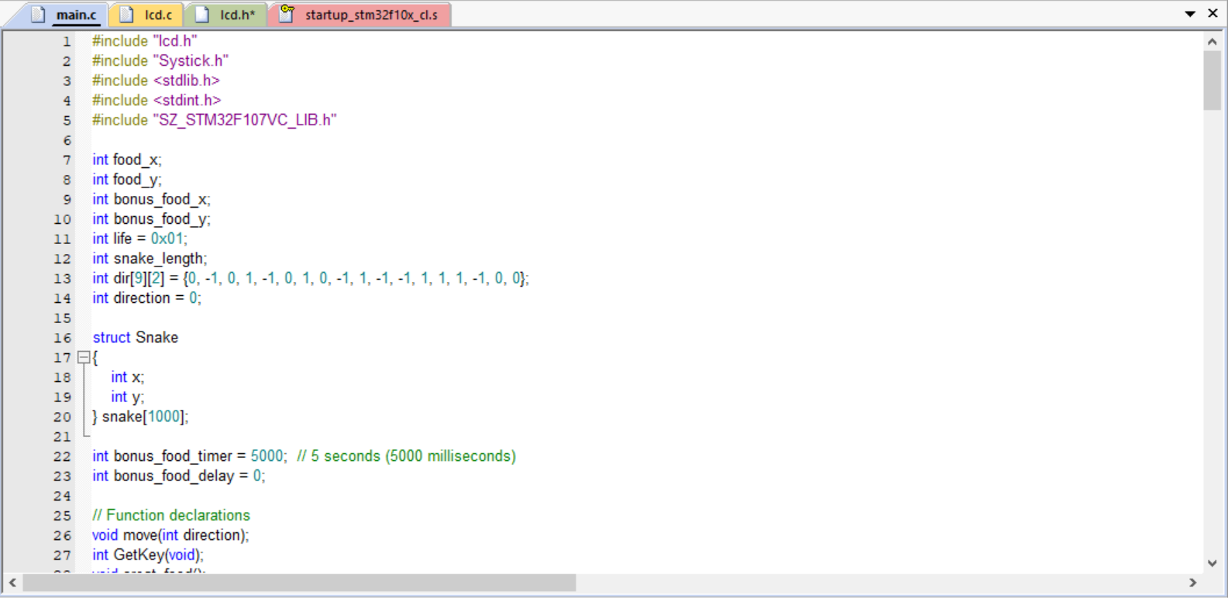

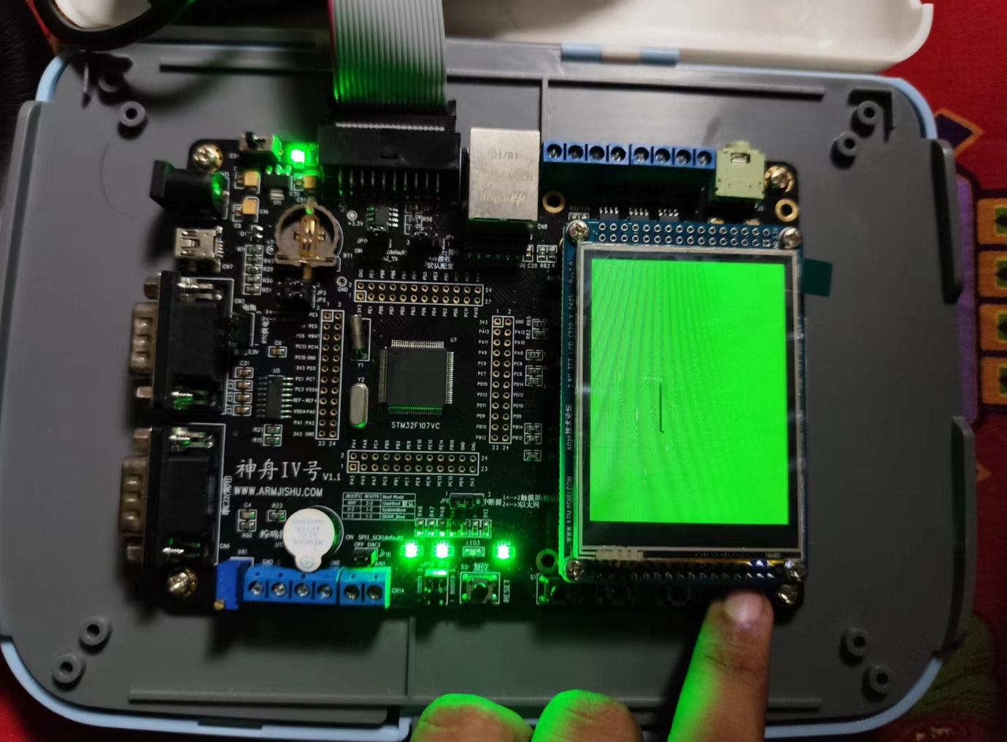

int main(void) {

// Initialization

SZ_STM32_SysTickInit(1000000);

SZ_STM32_LCDInit();

// ... (LEDs, keys, clearing LCD, snake initialization, and initial food creation)

while (1) {

// Game loop

direction = GetKey();

move(direction);

// Update bonus food delay timer

if (bonus_food_delay > 0) {

bonus_food_delay -= 100; // Decrease by 100 milliseconds

if (bonus_food_delay <= 0) {

bonus_food_delay = 0;

creat_bonus_food(); // Create bonus food after the delay

}

}

}

}

**3.3.5 Movement Function:**



void move(int direction) {

// ... (snake movement, collision detection with boundaries and food)

Big_Point(snake[0].x, snake[0].y, LCD_COLOR_BLACK);

}

**3.3.6 key Input Handling:**

int GetKey(void) {

int Key_Num = 0;

// ... (key input handling using STM32_KEYGetState)

return Key_Num;

}

Draws a point on the LCD, simulating a larger point by drawing it in multiple adjacent positions.

void snake_init(int x, int y)

{

int i;

snake_length = 0;

for (i = 0; i < 20; i++)

{

Big_Point(x, y, LCD_COLOR_BLACK);

snake[snake_length].x = x;

snake[snake_length].y = y;

snake_length++;

y -= 3;

}

}

**3.3.7 Food Generation Functions:**



void creat_food() {

// ... (generates random coordinates for regular food)

Big_Point(food_x, food_y, LCD_COLOR_BLACK);

}

void creat_bonus_food() {

// ... (generates bonus food after a delay, resets the delay timer)

Big_Point(bonus_food_x, bonus_food_y, LCD_COLOR_RED);

}

3.3.4 Typical D-link list operation

int dlink_append_last(void *pval)

{

node *pnode=create_node(pval);

if (!pnode)

return -1;

pnode->next = phead; //insert before phead

pnode->prev = phead->prev;

phead->prev->next = pnode;

phead->prev = pnode;

count++;

return 0;

void Init_snake() //control snake with dlink

{ struct part *body;

head=(struct part*)malloc(sizeof(struct part));

tail=(struct part*)malloc(sizeof(struct part));

body=(struct part*)malloc(sizeof(struct part));

body->x=21;

body->y=10;

body->next=NULL;

body->per=NULL;

snake_map[21][10]=1;

head->next=body;

tail->per=body;

size=1;

Display(tail->per->x*3+1,tail->per->y*3+1);

//begin at the middle point 64*32

}

**3.3.8 Snake Initialization Function**

void snake_init(int x, int y) {

// ... (initializes the snake at a given position)

Big_Point(x, y, LCD_COLOR_BLACK);

}

**3.3.9 Display Function**

**void Big_Point(int x, int y, int color) {**

**// ... (displays a point on the LCD using LCD_SetPoint)**

**delay(29000);**

**}**

**3.3.8 snake map[]**

* **Snake map[] is used to record the location of the snake and decide whether to eat it.**
* **That is to say, each time we only need to determine whether the corresponding point of map is 1.If each snake traverses every point, the time complexity is high.**
* **To judge whether you eat yourself, you have to go through the whole snake, but if I store it in map according to the corresponding coordinates when drawing snakes, I will find the corresponding point directly when judging, so I don't need to go through the snake.**

**unsigned int display_snake()**

**{**

**struct part *body;**

**body=(struct part*)malloc(sizeof(struct part));**

**body->x=head_x;**

**body->y=head_y;**

**head->next->per=body;**

**body->next=head->next;**

**head->next=body;**

**Display(head_x*3+1,head_y*3+1);**

**if(snake_map[head_x][head_y]==1) return 0;**

**else snake_map[head_x][head_y]=1;**

**if(head_x==X&&head_y==Y) {**

**food();**

**size++; }**

**else {**

**snake_map[tail->per->x][tail->per->y]=0;**

**Clear(tail->per->x*3+1,tail->per->y*3+1);**

**tail->per=tail->per->per;**

**free(tail->per->next);**

**}**

**return 1;**

**}**

**3.4 Another method to design software**



**4. SYSTEM DESIGN**

**4.1 Complete System Diagram (Hardware)**

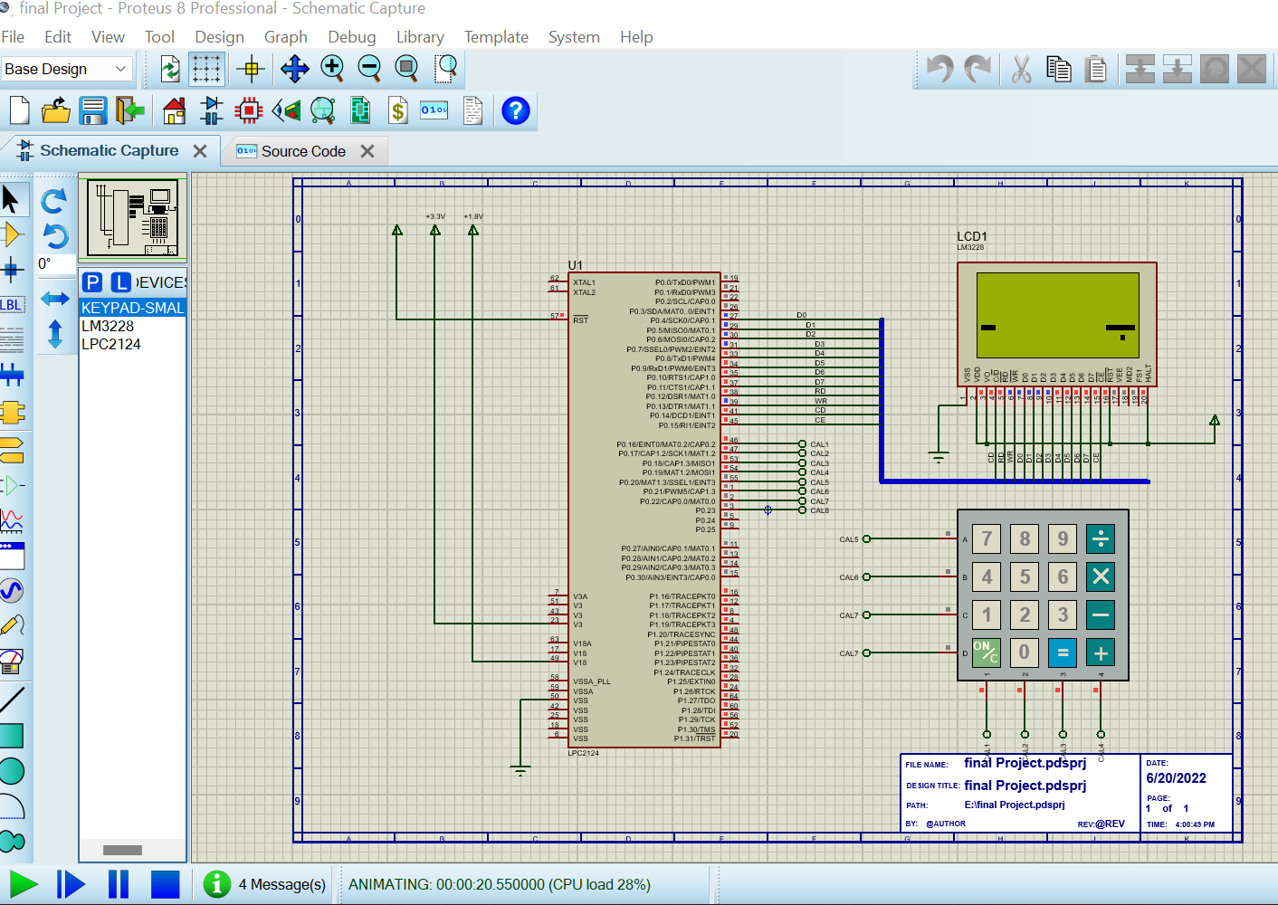

**Figure 14: Complete System Diagram (Hardware)**

**4.2 Complete System Diagram (Software)**

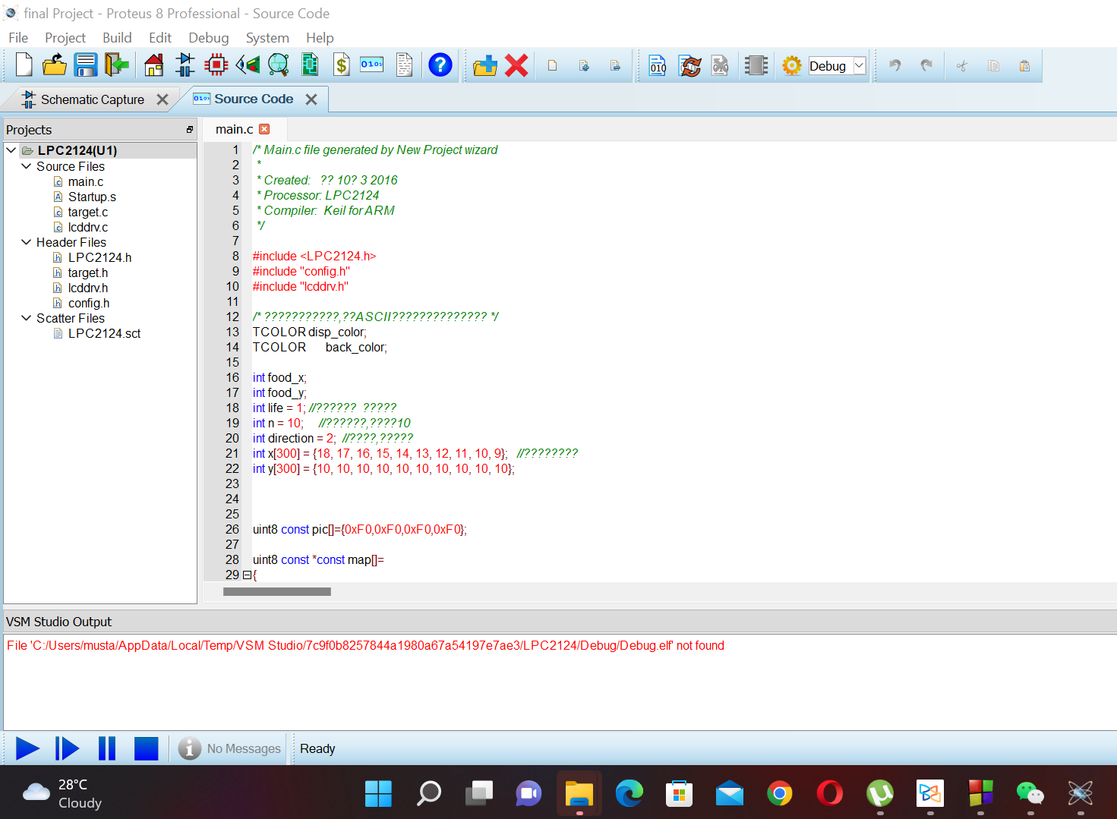

**Figure 15: Complete System Diagram (Software)**

**4.2.1 Game Running**



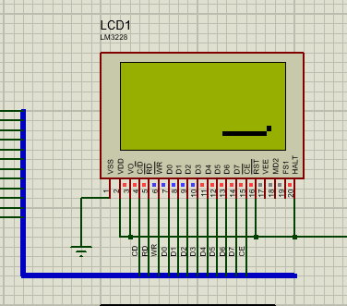



**Figure 16: Game running-1**

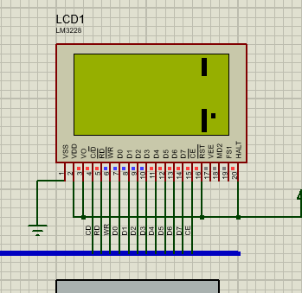



**Figure 17: Game running 2**

**4.2.2 Game Over**

Game playing time, when snake bite his body. The game is over.

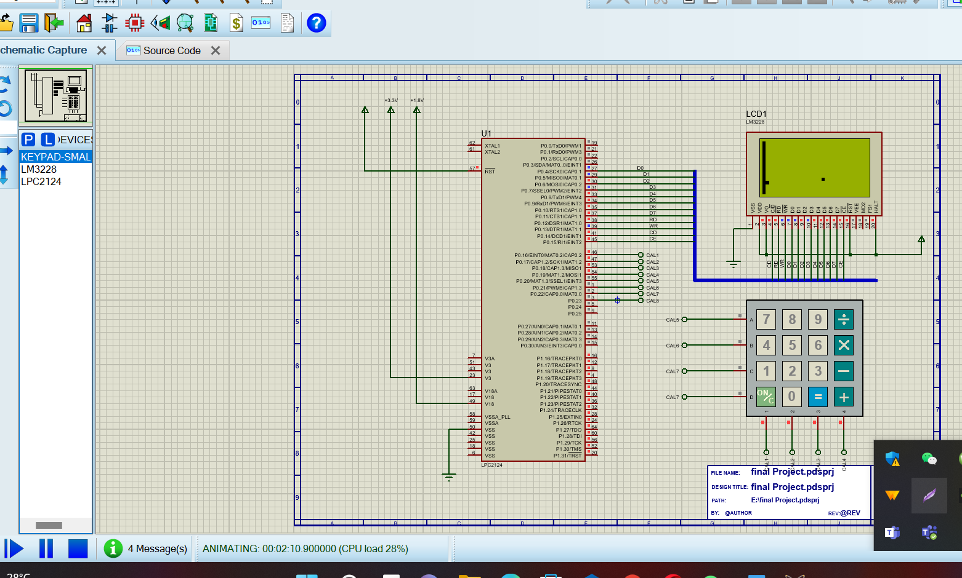

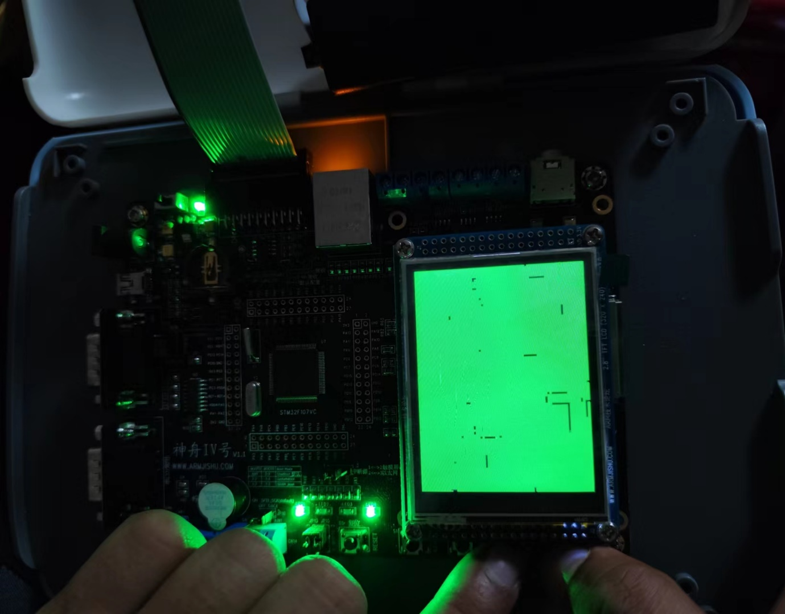

**Figure 18: Game over**

**4.2.3 New Game**

**When game is over then starting a new game.**

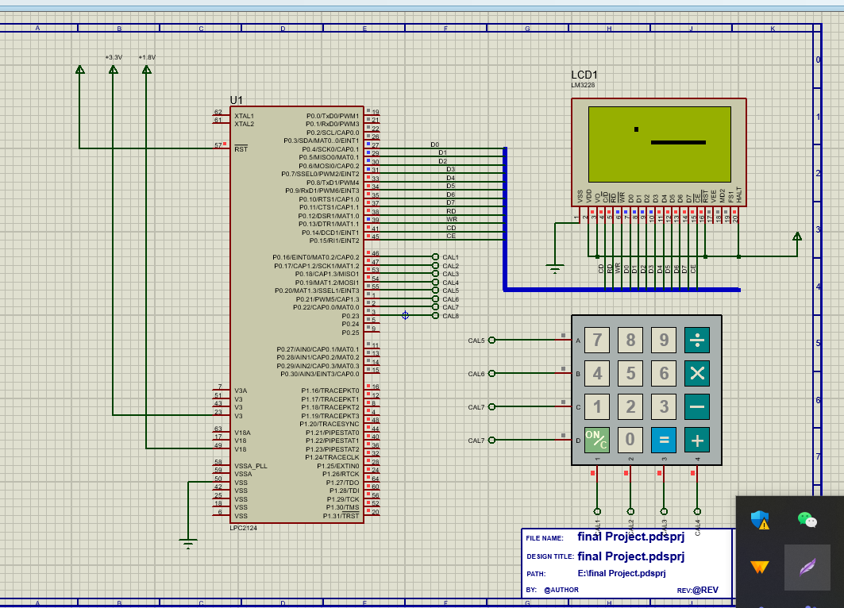



**Figure 19: New game**

**5. DISCUSSION & REFERENCE**

**5.1 Discussions**

The coding of Snake was extremely difficult with many errors arising. Many systems had to be written numerous ways before a final working solution was found. For example, two different movement methods were used prior to final version; however, even the final version is flawed as vertical movement causes the snake to change scale. There were also issues with the food – snake collision detection. While the final version resulted in a snake that could eat food, the movement glitch caused the food to cause further size issues.

Despite the fact that the game could not truly be played due to the fact no score could be given, the game is still satisfying. With the exception of the size glitch when turning, the snake responds to user input and moves around the screen as directed. Given longer to work on this, the collision detection with the movement would be the first thing fixed. By fixing this, all other sections of code that are currently not working would run. The leaderboard would work as there would be correct scores input, and the snake would grow as the food would cause it to only increase by one and not varying numbers based on direction. In addition, fixing the movement would allow for the snake to die when colliding with itself. In the current state, the snake moves as a matrix so it can not kill itself as it would be impossible to move in any direction. This failure to establish a perfect movement system was the biggest disappointment of the game as all other problems stemmed from it.

For these reasons, it is recommended that anyone who wishes to recreate this game starts simply when writing the code. It is advisable that they first perfect the snake movement controls before messing with the food generation. By taking the code in small sections, it is easier to get individual features to work. Building off this, use functions to contain each aspect of the game. Using functions made it easier to determine where errors were occurring when debugging the code. It also kept the code more organized.

**5.2 References**

[**https://www.w3schools.com/**](https://www.w3schools.com/)

[**https://stackoverflow.com/**](https://stackoverflow.com/)

[**https://www.geeksforgeeks.org/**](https://www.geeksforgeeks.org/)

[**https://wenku.baidu.com/**](https://wenku.baidu.com/)

**6. CODE**

**6.1 main.c**





**// Main.c file generated by New Project wizard**



**#include "lcd.h"**

**#include "Systick.h"**

**#include <stdlib.h>**

**#include <stdint.h>**

**#include "SZ_STM32F107VC_LIB.h"**

**int food_x;**

**int food_y;**

**int bonus_food_x;**

**int bonus_food_y;**

**int life = 0x01;**

**int snake_length;**

**int dir[9][2] = {0, -1, 0, 1, -1, 0, 1, 0, -1, 1, -1, -1, 1, 1, 1, -1, 0, 0};**

**int direction = 0;**

**struct Snake**

**{**

**int x;**

**int y;**

**} snake[1000];**

**int bonus_food_timer = 5000; // 5 seconds (5000 milliseconds)**

**int bonus_food_delay = 0;**

**// Function declarations**

**void move(int direction);**

**int GetKey(void);**

**void creat_food();**

**void creat_bonus_food();**

**void snake_init(int x, int y);**

**void Big_Point(int x, int y, int color);**

**int main(void)**

**{**

**SZ_STM32_SysTickInit(1000000);**

**SZ_STM32_LCDInit();**

**SZ_STM32_LEDInit(LED1);**

**SZ_STM32_LEDInit(LED2);**

**SZ_STM32_LEDInit(LED3);**

**SZ_STM32_LEDInit(LED4);**

**SZ_STM32_KEYInit(KEY1, BUTTON_MODE_GPIO);**

**SZ_STM32_KEYInit(KEY2, BUTTON_MODE_GPIO);**

**SZ_STM32_KEYInit(KEY3, BUTTON_MODE_GPIO);**

**SZ_STM32_KEYInit(KEY4, BUTTON_MODE_GPIO);**

**LCD_Clear(LCD_COLOR_GREEN);**

**snake_init(64, 240);**

**creat_food();**

**creat_bonus_food();**

**while (1)**

**{**

**direction = GetKey();**

**move(direction);**

**// Update bonus food delay timer**

**if (bonus_food_delay > 0)**

**{**

**bonus_food_delay -= 100; // Decrease by 100 milliseconds**

**if (bonus_food_delay <= 0)**

**{**

**bonus_food_delay = 0;**

**creat_bonus_food(); // Create bonus food after the delay**

**}**

**}**

**}**

**}**

**void move(int direction)**

**{**

**int i;**

**struct Snake last;**

**last = snake[snake_length - 1];**

**for (i = snake_length - 1; i > 0; i--)**

**{**

**snake[i] = snake[i - 1];**

**}**

**snake[0].x += dir[direction][0] * 3;**

**snake[0].y += dir[direction][1] * 3;**

**if (snake[0].x >= 239)**

**snake[0].x = 1;**

**else if (snake[0].x <= 0)**

**snake[0].x = 238;**

**else if (snake[0].y <= 0)**

**snake[0].y = 319;**

**else if (snake[0].y >= 319)**

**snake[0].y = 1;**

**for (i = 1; i < snake_length - 1; i++)**

**{**

**if (snake[i].x + 2 >= snake[0].x && snake[0].x >= snake[i].x - 2 && snake[i].y + 2 >= snake[0].y && snake[0].y >= snake[i].y - 2)**

**{**

**life = 0;**

**return;**

**}**

**}**

**if (snake[0].x + 2 >= food_x && food_x >= snake[0].x - 2 && snake[0].y + 2 >= food_y && food_y >= snake[0].y - 2)**

**{**

**snake[snake_length] = last;**

**creat_food();**

**snake_length++;**

**}**

**else if (snake[0].x + 2 >= bonus_food_x && bonus_food_x >= snake[0].x - 2 && snake[0].y + 2 >= bonus_food_y && bonus_food_y >= snake[0].y - 2)**

**{**

**snake[snake_length] = last;**

**creat_bonus_food();**

**snake_length++;**

**}**

**else**

**{**

**Big_Point(last.x, last.y, LCD_COLOR_GREEN);**

**}**

**Big_Point(snake[0].x, snake[0].y, LCD_COLOR_BLACK);**

**}**

**int GetKey(void)**

**{**

**int Key_Num = 0;**

**if (SZ_STM32_KEYGetState(KEY1) == 0)**

**{**

**delay(150000);**

**if (SZ_STM32_KEYGetState(KEY1) == 0)**

**{**

**Key_Num = 0;**

**SZ_STM32_LEDToggle(LED1);**

**}**

**}**

**else if (SZ_STM32_KEYGetState(KEY2) == 0)**

**{**

**delay(150000);**

**if (SZ_STM32_KEYGetState(KEY2) == 0)**

**{**

**Key_Num = 1;**

**SZ_STM32_LEDToggle(LED2);**

**}**

**}**

**else if (SZ_STM32_KEYGetState(KEY3) == 0)**

**{**

**delay(150000);**

**if (SZ_STM32_KEYGetState(KEY3) == 0)**

**{**

**Key_Num = 2;**

**SZ_STM32_LEDToggle(LED3);**

**}**

**}**

**else if (SZ_STM32_KEYGetState(KEY4) == 0)**

**{**

**delay(150000);**

**if (SZ_STM32_KEYGetState(KEY4) == 0)**

**{**

**Key_Num = 3;**

**SZ_STM32_LEDToggle(LED4);**

**}**

**}**

**return Key_Num;**

**}**

**void creat_food()**

**{**

**int i, flag = 1;**

**Big_Point(food_x, food_y, LCD_COLOR_GREEN);**

**do**

**{**

**food_x = rand() % 120;**

**food_y = rand() % 160;**

**for (i = 0; i < snake_length - 1; i++)**

**{**

**if (snake[i].x + 2 <= food_x || food_x <= snake[i].x - 2 || snake[i].y + 2 <= food_y || food_y <= snake[i].y - 2)**

**flag = 0;**

**}**

**} while (flag);**

**Big_Point(food_x, food_y, LCD_COLOR_BLACK);**

**}**

**void creat_bonus_food()**

**{**

**// Check if enough time has passed for bonus food**

**if (bonus_food_timer == 0)**

**{**

**int i, flag = 1;**

**Big_Point(bonus_food_x, bonus_food_y, LCD_COLOR_GREEN);**

**do**

**{**

**bonus_food_x = rand() % 120;**

**bonus_food_y = rand() % 160;**

**for (i = 0; i < snake_length - 1; i++)**

**{**

**if (snake[i].x + 2 <= bonus_food_x || bonus_food_x <= snake[i].x - 2 || snake[i].y + 2 <= bonus_food_y || bonus_food_y <= snake[i].y - 2)**

**flag = 0;**

**}**

**} while (flag);**

**Big_Point(bonus_food_x, bonus_food_y, LCD_COLOR_RED);**

**bonus_food_delay = bonus_food_timer; // Reset the delay timer**

**}**

**else**

**{**

**bonus_food_timer = 0; // Start the 5-second timer**

**}**

**}**

**void snake_init(int x, int y)**

**{**

**int i;**

**snake_length = 0;**

**for (i = 0; i < 20; i++)**

**{**

**Big_Point(x, y, LCD_COLOR_BLACK);**

**snake[snake_length].x = x;**

**snake[snake_length].y = y;**

**snake_length++;**

**y -= 3;**

**}**

**}**

**void Big_Point(int x, int y, int color)**

**{**

**int i;**

**for (i = 0; i < 9; i++)**

**{**

**LCD_SetPoint(x + dir[i][0], y + dir[i][1], color);**

**delay(29000);**

**}**

**}**



**6.2 lcddrv.c**

**#ifdef __cplusplus**

**extern "C" {**

**#endif**

**#include "stm32f10x.h"**

**/* ÉñÖÛIVºÅLCD¹Ü½ÅÏà¹Ø¶¨Òå www.armjishu.com Team */**

**#define LCD_PinNum_WR 14**

**#define LCD_Pin_WR GPIO_Pin_14**

**#define LCD_PORT_WR GPIOB**

**#define LCD_CLK_WR RCC_APB2Periph_GPIOB**

**#define LCD_PinNum_CS 8**

**#define LCD_Pin_CS GPIO_Pin_8**

**#define LCD_PORT_CS GPIOC**

**#define LCD_CLK_CS RCC_APB2Periph_GPIOC**

**#define LCD_PinNum_RS 13**

**#define LCD_Pin_RS GPIO_Pin_13**

**#define LCD_PORT_RS GPIOD**

**#define LCD_CLK_RS RCC_APB2Periph_GPIOD**

**#define LCD_PinNum_RD 15**

**#define LCD_Pin_RD GPIO_Pin_15**

**#define LCD_PORT_RD GPIOD**

**#define LCD_CLK_RD RCC_APB2Periph_GPIOD**

**#define LCD_PIN_DATA GPIO_Pin_All**

**#define LCD_PORT_DAT GPIOE**

**#define LCD_CLK_DATA RCC_APB2Periph_GPIOE**

**/* ÉñÖÛIVºÅLCD¼Ä´æÆ÷Ïà¹Ø¶¨Òå LCD Registers www.armjishu.com Team */**

**#define LCD_REG_0 0x00**

**#define LCD_REG_1 0x01**

**#define LCD_REG_2 0x02**

**#define LCD_REG_3 0x03**

**#define LCD_REG_4 0x04**

**#define LCD_REG_5 0x05**

**#define LCD_REG_6 0x06**

**#define LCD_REG_7 0x07**

**#define LCD_REG_8 0x08**

**#define LCD_REG_9 0x09**

**#define LCD_REG_10 0x0A**

**#define LCD_REG_12 0x0C**

**#define LCD_REG_13 0x0D**

**#define LCD_REG_14 0x0E**

**#define LCD_REG_15 0x0F**

**#define LCD_REG_16 0x10**

**#define LCD_REG_17 0x11**

**#define LCD_REG_18 0x12**

**#define LCD_REG_19 0x13**

**#define LCD_REG_20 0x14**

**#define LCD_REG_21 0x15**

**#define LCD_REG_22 0x16**

**#define LCD_REG_23 0x17**

**#define LCD_REG_24 0x18**

**#define LCD_REG_25 0x19**

**#define LCD_REG_26 0x1A**

**#define LCD_REG_27 0x1B**

**#define LCD_REG_28 0x1C**

**#define LCD_REG_29 0x1D**

**#define LCD_REG_30 0x1E**

**#define LCD_REG_31 0x1F**

**#define LCD_REG_32 0x20**

**#define LCD_REG_33 0x21**

**#define LCD_REG_34 0x22**

**#define LCD_REG_36 0x24**

**#define LCD_REG_37 0x25**

**#define LCD_REG_40 0x28**

**#define LCD_REG_41 0x29**

**#define LCD_REG_43 0x2B**

**#define LCD_REG_45 0x2D**

**#define LCD_REG_48 0x30**

**#define LCD_REG_49 0x31**

**#define LCD_REG_50 0x32**

**#define LCD_REG_51 0x33**

**#define LCD_REG_52 0x34**

**#define LCD_REG_53 0x35**

**#define LCD_REG_54 0x36**

**#define LCD_REG_55 0x37**

**#define LCD_REG_56 0x38**

**#define LCD_REG_57 0x39**

**#define LCD_REG_59 0x3B**

**#define LCD_REG_60 0x3C**

**#define LCD_REG_61 0x3D**

**#define LCD_REG_62 0x3E**

**#define LCD_REG_63 0x3F**

**#define LCD_REG_64 0x40**

**#define LCD_REG_65 0x41**

**#define LCD_REG_66 0x42**

**#define LCD_REG_67 0x43**

**#define LCD_REG_68 0x44**

**#define LCD_REG_69 0x45**

**#define LCD_REG_70 0x46**

**#define LCD_REG_71 0x47**

**#define LCD_REG_72 0x48**

**#define LCD_REG_73 0x49**

**#define LCD_REG_74 0x4A**

**#define LCD_REG_75 0x4B**

**#define LCD_REG_76 0x4C**

**#define LCD_REG_77 0x4D**

**#define LCD_REG_78 0x4E**

**#define LCD_REG_79 0x4F**

**#define LCD_REG_80 0x50**

**#define LCD_REG_81 0x51**

**#define LCD_REG_82 0x52**

**#define LCD_REG_83 0x53**

**#define LCD_REG_96 0x60**

**#define LCD_REG_97 0x61**

**#define LCD_REG_106 0x6A**

**#define LCD_REG_118 0x76**

**#define LCD_REG_128 0x80**

**#define LCD_REG_129 0x81**

**#define LCD_REG_130 0x82**

**#define LCD_REG_131 0x83**

**#define LCD_REG_132 0x84**

**#define LCD_REG_133 0x85**

**#define LCD_REG_134 0x86**

**#define LCD_REG_135 0x87**

**#define LCD_REG_136 0x88**

**#define LCD_REG_137 0x89**

**#define LCD_REG_139 0x8B**

**#define LCD_REG_140 0x8C**

**#define LCD_REG_141 0x8D**

**#define LCD_REG_143 0x8F**

**#define LCD_REG_144 0x90**

**#define LCD_REG_145 0x91**

**#define LCD_REG_146 0x92**

**#define LCD_REG_147 0x93**

**#define LCD_REG_148 0x94**

**#define LCD_REG_149 0x95**

**#define LCD_REG_150 0x96**

**#define LCD_REG_151 0x97**

**#define LCD_REG_152 0x98**

**#define LCD_REG_153 0x99**

**#define LCD_REG_154 0x9A**

**#define LCD_REG_157 0x9D**

**#define LCD_REG_192 0xC0**

**#define LCD_REG_193 0xC1**

**#define LCD_REG_229 0xE5**

**/* ÉñÖÛIVºÅLCD²ÊÆÁ³£ÓÃ»ù±¾ÑÕÉ«¶¨Òå LCD color www.armjishu.com Team */**

**#define LCD_COLOR_WHITE 0xFFFF**

**#define LCD_COLOR_BLACK 0x0000**

**#define LCD_COLOR_GREY 0xE79C**

**#define LCD_COLOR_BLUE 0x001F**

**#define LCD_COLOR_BLUE2 0x051F**

**#define LCD_COLOR_RED 0xF800**

**#define LCD_COLOR_MAGENTA 0xF81F**

**#define LCD_COLOR_GREEN 0x07E0**

**#define LCD_COLOR_CYAN 0x7FFF**

**#define LCD_COLOR_YELLOW 0xFFE0**

**/* ÉñÖÛIVºÅLCD²ÊÆÁ»­ÏßµÈº¯ÊýµÄ·½ÏòDirection¶¨Òå www.armjishu.com Team */**

**#define LCD_DIR_HORIZONTAL 0x0000**

**#define LCD_DIR_VERTICAL 0x0001**

**/* ÉñÖÛIVºÅLCD²ÊÆÁ·Ö±æÂÊ¶¨Òå ¿íºÍ¸ß www.armjishu.com Team */**

**#define LCD_PIXEL_WIDTH 0x0140 /* ¿í320 */**

**#define LCD_PIXEL_HEIGHT 0x00F0 /* ¸ß240 */**

**/* ÉñÖÛIVºÅLCD²ÊÆÁº¯ÊýÉùÃ÷ www.armjishu.com Team */**

**void SZ_STM32_LCDInit(void);**

**void LCD_SetCursor(uint16_t Xpos, uint16_t Ypos);**

**void LCD_Clear(uint16_t Color);**

**void LCD_SetPoint(uint16_t Xpos, uint16_t Ypos, uint16_t Color);**

**void LCD_WriteRegIndex(uint8_t LCD_Reg);**

**void LCD_WriteReg(uint8_t LCD_Reg, uint16_t LCD_RegValue);**

**void LCD_WriteRAM_Prepare(void);**

**void LCD_WriteRAMWord(uint16_t RGB_Code);**

**uint16_t LCD_ReadReg(uint8_t LCD_Reg);**

**void LCD_WriteRAM(uint16_t RGB_Code);**

**void LCD_Pins_Config(void);**

**#ifdef __cplusplus**

**}**

**#endif**





**6.3 target.c**

**#define IN_TARGET**

**#include "config.h"**

**void __irq IRQ_Exception(void)**

**{**

**while(1); // 这一句替换为自己的代码**

**}**

**void FIQ_Exception(void)**

**{**

**while(1); // 这一句替换为自己的代码**

**}**

**void TargetInit(void)**

**{**

**/* write something*/**

**}**

**void TargetResetInit(void)**

**{**

**/* code here*/**

**/* PLLCON = 1;**

**#if ((Fcclk / 4) / Fpclk) == 1**

**VPBDIV = 0;**

**#endif**

**#if ((Fcclk / 4) / Fpclk) == 2**

**VPBDIV = 2;**

**#endif**

**#if ((Fcclk / 4) / Fpclk) == 4**

**VPBDIV = 1;**

**#endif**

**#if (Fcco / Fcclk) == 2**

**PLLCFG = ((Fcclk / Fosc) - 1) | (0 << 5);**

**#endif**

**#if (Fcco / Fcclk) == 4**

**PLLCFG = ((Fcclk / Fosc) - 1) | (1 << 5);**

**#endif**

**#if (Fcco / Fcclk) == 8**

**PLLCFG = ((Fcclk / Fosc) - 1) | (2 << 5);**

**#endif**

**#if (Fcco / Fcclk) == 16**

**PLLCFG = ((Fcclk / Fosc) - 1) | (3 << 5);**

**#endif**

**PLLFEED = 0xaa;**

**PLLFEED = 0x55;**

**while((PLLSTAT & (1 << 10)) == 0);**

**PLLCON = 3;**

**PLLFEED = 0xaa;**

**PLLFEED = 0x55;**

**\*/**

**/* 设置存储器加速模块 */**

**MAMCR = 2; //MAMCR 8u2 00－MAM 功能被禁止、01－MAM功能部分使能、10－MAM功能完全使能**

**/* MAMTIM 8u3**

**000＝0－保留**

**001＝1－一段时间内只有 1 个处理器时钟（cclk）用于 MAM 取指。**

**010＝2－一段时间内只有2个处理器时钟（cclk）用于MAM取指。**

**011＝3－一段时间内只有 3 个处理器时钟（cclk）用于 MAM 取指。**

**100＝4－一段时间内只有4个处理器时钟（cclk）用于 MAM 取指。**

**101＝5－一段时间内只有5 个处理器时钟（cclk）用于 MAM 取指。**

**110＝6－一段时间内只有 6 个处理器时钟（cclk）用于 MAM 取指。**

**111＝7－一段时间内只有7个处理器时钟（cclk）用于 MAM 取指。**

**\*/**

**#if Fcclk < 20000000**

**MAMTIM = 1;**

**#else**

**#if Fcclk < 40000000**

**MAMTIM = 2;**

**#else**

**MAMTIM = 3;**

**#endif**

**#endif**

**/* 初始化VIC */**

**VICIntEnClr = 0xffffffff;//清所有中断使能，即关中断**

**VICVectAddr = 0;//默认向量地址寄存器**

**VICIntSelect = 0;//1：对应的中断请求分配为FIQ。0：对应的中断请求分配为IRQ。**

**/* 添加自己的代码 */**

**}**

**#include "rt_sys.h"**

**#include "stdio.h"**

**#pragma import(__use_no_semihosting_swi)**

**#pragma import(__use_two_region_memory)**

**int __rt_div0(int a)**

**{**

**a = a;**

**return 0;**

**}**

**int fputc(int ch,FILE *f)**

**{**

**ch = ch;**

**f = f;**

**return 0;**

**}**

**int fgetc(FILE *f)**

**{**

**f = f;**

**return 0;**

**}**

**int _sys_close(FILEHANDLE fh)**

**{**

**fh = fh;**

**return 0;**

**}**

**int _sys_write(FILEHANDLE fh, const unsigned char * buf,**

**unsigned len, int mode)**

**{**

**fh = fh;**

**buf = buf;**

**len =len;**

**mode = mode;**

**return 0;**

**}**

**int _sys_read(FILEHANDLE fh, unsigned char * buf,**

**unsigned len, int mode)**

**{**

**fh = fh;**

**buf = buf;**

**len =len;**

**mode = mode;**

**return 0;**

**}**

**void _ttywrch(int ch)**

**{**

**ch = ch;**

**}**

**int _sys_istty(FILEHANDLE fh)**

**{**

**fh = fh;**

**return 0;**

**}**

**int _sys_seek(FILEHANDLE fh, long pos)**

**{**

**fh = fh;**

**return 0;**

**}**

**int _sys_ensure(FILEHANDLE fh)**

**{**

**fh = fh;**

**return 0;**

**}**

**long _sys_flen(FILEHANDLE fh)**

**{**

**fh = fh;**

**return 0;**

**}**

**int _sys_tmpnam(char * name, int sig, unsigned maxlen)**

**{**

**name = name;**

**sig = sig;**

**maxlen = maxlen;**

**return 0;**

**}**

**void _sys_exit(int returncode)**

**{**

**returncode = returncode;**

**}**

**char *_sys_command_string(char * cmd, int len)**

**{**

**cmd = cmd;**

**len = len;**

**return 0;**

**}**



**6.4 Startup.s**

**;********************************************************************************************************/**

**;* File Name : startup_stm32f10x_cl.s**

**;* Author : MCD Application Team**

**;* Version : V3.5.0**

**;* Date : 11-March-2011**

**;* Description : STM32F10x Connectivity line devices vector table for MDK-ARM**

**;* toolchain.**

**;* This module performs:**

**;* - Set the initial SP**

**;* - Set the initial PC == Reset_Handler**

**;* - Set the vector table entries with the exceptions ISR address**

**;* - Configure the clock system**

**;* - Branches to __main in the C library (which eventually**

**;* calls main()).**

**;* After Reset the CortexM3 processor is in Thread mode,**

**;* priority is Privileged, and the Stack is set to Main.**

**;* <<< Use Configuration Wizard in Context Menu >>>**

**;\*\*\*\*\*\*\*\*\*\*\*\*\*\*\*\*\*\*\*\*\*\*\*\*\*\*\*\*\*\*\*\*\*\*\*\*\*\*\*\*\*\*\*\*\*\*\*\*\*\*\*\*\*\*\*\*\*\*\*\*\*\*\*\*\*\*\*\*\*\*\*\*\*\*\*\*\*\*\***

**; THE PRESENT FIRMWARE WHICH IS FOR GUIDANCE ONLY AIMS AT PROVIDING CUSTOMERS**

**; WITH CODING INFORMATION REGARDING THEIR PRODUCTS IN ORDER FOR THEM TO SAVE TIME.**

**; AS A RESULT, STMICROELECTRONICS SHALL NOT BE HELD LIABLE FOR ANY DIRECT,**

**; INDIRECT OR CONSEQUENTIAL DAMAGES WITH RESPECT TO ANY CLAIMS ARISING FROM THE**

**; CONTENT OF SUCH FIRMWARE AND/OR THE USE MADE BY CUSTOMERS OF THE CODING**

**; INFORMATION CONTAINED HEREIN IN CONNECTION WITH THEIR PRODUCTS.**

**;\*\*\*\*\*\*\*\*\*\*\*\*\*\*\*\*\*\*\*\*\*\*\*\*\*\*\*\*\*\*\*\*\*\*\*\*\*\*\*\*\*\*\*\*\*\*\*\*\*\*\*\*\*\*\*\*\*\*\*\*\*\*\*\*\*\*\*\*\*\*\*\*\*\*\*\*\*\*\***

**; Amount of memory (in bytes) allocated for Stack**

**; Tailor this value to your application needs**

**; <h> Stack Configuration**

**; <o> Stack Size (in Bytes) <0x0-0xFFFFFFFF:8>**

**; </h>**

**Stack_Size EQU 0x00000400**

**AREA STACK, NOINIT, READWRITE, ALIGN=3**

**Stack_Mem SPACE Stack_Size**

**__initial_sp**

**; <h> Heap Configuration**

**; <o> Heap Size (in Bytes) <0x0-0xFFFFFFFF:8>**

**; </h>**

**Heap_Size EQU 0x00000200**

**AREA HEAP, NOINIT, READWRITE, ALIGN=3**

**__heap_base**

**Heap_Mem SPACE Heap_Size**

**__heap_limit**

**PRESERVE8**

**THUMB**

**; Vector Table Mapped to Address 0 at Reset**

**AREA RESET, DATA, READONLY**

**EXPORT __Vectors**

**EXPORT __Vectors_End**

**EXPORT __Vectors_Size**

**__Vectors DCD __initial_sp ; Top of Stack**

**DCD Reset_Handler ; Reset Handler**

**DCD NMI_Handler ; NMI Handler**

**DCD HardFault_Handler ; Hard Fault Handler**

**DCD MemManage_Handler ; MPU Fault Handler**

**DCD BusFault_Handler ; Bus Fault Handler**

**DCD UsageFault_Handler ; Usage Fault Handler**

**DCD 0 ; Reserved**

**DCD 0 ; Reserved**

**DCD 0 ; Reserved**

**DCD 0 ; Reserved**

**DCD SVC_Handler ; SVCall Handler**

**DCD DebugMon_Handler ; Debug Monitor Handler**

**DCD 0 ; Reserved**

**DCD PendSV_Handler ; PendSV Handler**

**DCD SysTick_Handler ; SysTick Handler**

**; External Interrupts**

**DCD WWDG_IRQHandler ; Window Watchdog**

**DCD PVD_IRQHandler ; PVD through EXTI Line detect**

**DCD TAMPER_IRQHandler ; Tamper**

**DCD RTC_IRQHandler ; RTC**

**DCD FLASH_IRQHandler ; Flash**

**DCD RCC_IRQHandler ; RCC**

**DCD EXTI0_IRQHandler ; EXTI Line 0**

**DCD EXTI1_IRQHandler ; EXTI Line 1**

**DCD EXTI2_IRQHandler ; EXTI Line 2**

**DCD EXTI3_IRQHandler ; EXTI Line 3**

**DCD EXTI4_IRQHandler ; EXTI Line 4**

**DCD DMA1_Channel1_IRQHandler ; DMA1 Channel 1**

**DCD DMA1_Channel2_IRQHandler ; DMA1 Channel 2**

**DCD DMA1_Channel3_IRQHandler ; DMA1 Channel 3**

**DCD DMA1_Channel4_IRQHandler ; DMA1 Channel 4**

**DCD DMA1_Channel5_IRQHandler ; DMA1 Channel 5**

**DCD DMA1_Channel6_IRQHandler ; DMA1 Channel 6**

**DCD DMA1_Channel7_IRQHandler ; DMA1 Channel 7**

**DCD ADC1_2_IRQHandler ; ADC1 and ADC2**

**DCD CAN1_TX_IRQHandler ; CAN1 TX**

**DCD CAN1_RX0_IRQHandler ; CAN1 RX0**

**DCD CAN1_RX1_IRQHandler ; CAN1 RX1**

**DCD CAN1_SCE_IRQHandler ; CAN1 SCE**

**DCD EXTI9_5_IRQHandler ; EXTI Line 9..5**

**DCD TIM1_BRK_IRQHandler ; TIM1 Break**

**DCD TIM1_UP_IRQHandler ; TIM1 Update**

**DCD TIM1_TRG_COM_IRQHandler ; TIM1 Trigger and Commutation**

**DCD TIM1_CC_IRQHandler ; TIM1 Capture Compare**

**DCD TIM2_IRQHandler ; TIM2**

**DCD TIM3_IRQHandler ; TIM3**

**DCD TIM4_IRQHandler ; TIM4**

**DCD I2C1_EV_IRQHandler ; I2C1 Event**

**DCD I2C1_ER_IRQHandler ; I2C1 Error**

**DCD I2C2_EV_IRQHandler ; I2C2 Event**

**DCD I2C2_ER_IRQHandler ; I2C1 Error**

**DCD SPI1_IRQHandler ; SPI1**

**DCD SPI2_IRQHandler ; SPI2**

**DCD USART1_IRQHandler ; USART1**

**DCD USART2_IRQHandler ; USART2**

**DCD USART3_IRQHandler ; USART3**

**DCD EXTI15_10_IRQHandler ; EXTI Line 15..10**

**DCD RTCAlarm_IRQHandler ; RTC alarm through EXTI line**

**DCD OTG_FS_WKUP_IRQHandler ; USB OTG FS Wakeup through EXTI line**

**DCD 0 ; Reserved**

**DCD 0 ; Reserved**

**DCD 0 ; Reserved**

**DCD 0 ; Reserved**

**DCD 0 ; Reserved**

**DCD 0 ; Reserved**

**DCD 0 ; Reserved**

**DCD TIM5_IRQHandler ; TIM5**

**DCD SPI3_IRQHandler ; SPI3**

**DCD UART4_IRQHandler ; UART4**

**DCD UART5_IRQHandler ; UART5**

**DCD TIM6_IRQHandler ; TIM6**

**DCD TIM7_IRQHandler ; TIM7**

**DCD DMA2_Channel1_IRQHandler ; DMA2 Channel1**

**DCD DMA2_Channel2_IRQHandler ; DMA2 Channel2**

**DCD DMA2_Channel3_IRQHandler ; DMA2 Channel3**

**DCD DMA2_Channel4_IRQHandler ; DMA2 Channel4**

**DCD DMA2_Channel5_IRQHandler ; DMA2 Channel5**

**DCD ETH_IRQHandler ; Ethernet**

**DCD ETH_WKUP_IRQHandler ; Ethernet Wakeup through EXTI line**

**DCD CAN2_TX_IRQHandler ; CAN2 TX**

**DCD CAN2_RX0_IRQHandler ; CAN2 RX0**

**DCD CAN2_RX1_IRQHandler ; CAN2 RX1**

**DCD CAN2_SCE_IRQHandler ; CAN2 SCE**

**DCD OTG_FS_IRQHandler ; USB OTG FS**

**__Vectors_End**

**__Vectors_Size EQU __Vectors_End - __Vectors**

**AREA |.text|, CODE, READONLY**

**; Reset handler**

**Reset_Handler PROC**

**EXPORT Reset_Handler [WEAK]**

**IMPORT SystemInit**

**IMPORT __main**

**LDR R0, =SystemInit**

**BLX R0**

**LDR R0, =__main**

**BX R0**

**ENDP**

**; Dummy Exception Handlers (infinite loops which can be modified)**

**NMI_Handler PROC**

**EXPORT NMI_Handler [WEAK]**

**B .**

**ENDP**

**HardFault_Handler\**

**PROC**

**EXPORT HardFault_Handler [WEAK]**

**B .**

**ENDP**

**MemManage_Handler\**

**PROC**

**EXPORT MemManage_Handler [WEAK]**

**B .**

**ENDP**

**BusFault_Handler\**

**PROC**

**EXPORT BusFault_Handler [WEAK]**

**B .**

**ENDP**

**UsageFault_Handler\**

**PROC**

**EXPORT UsageFault_Handler [WEAK]**

**B .**

**ENDP**

**SVC_Handler PROC**

**EXPORT SVC_Handler [WEAK]**

**B .**

**ENDP**

**DebugMon_Handler\**

**PROC**

**EXPORT DebugMon_Handler [WEAK]**

**B .**

**ENDP**

**PendSV_Handler PROC**

**EXPORT PendSV_Handler [WEAK]**

**B .**

**ENDP**

**SysTick_Handler PROC**

**EXPORT SysTick_Handler [WEAK]**

**B .**

**ENDP**

**Default_Handler PROC**

**EXPORT WWDG_IRQHandler [WEAK]**

**EXPORT PVD_IRQHandler [WEAK]**

**EXPORT TAMPER_IRQHandler [WEAK]**

**EXPORT RTC_IRQHandler [WEAK]**

**EXPORT FLASH_IRQHandler [WEAK]**

**EXPORT RCC_IRQHandler [WEAK]**

**EXPORT EXTI0_IRQHandler [WEAK]**

**EXPORT EXTI1_IRQHandler [WEAK]**

**EXPORT EXTI2_IRQHandler [WEAK]**

**EXPORT EXTI3_IRQHandler [WEAK]**

**EXPORT EXTI4_IRQHandler [WEAK]**

**EXPORT DMA1_Channel1_IRQHandler [WEAK]**

**EXPORT DMA1_Channel2_IRQHandler [WEAK]**

**EXPORT DMA1_Channel3_IRQHandler [WEAK]**

**EXPORT DMA1_Channel4_IRQHandler [WEAK]**

**EXPORT DMA1_Channel5_IRQHandler [WEAK]**

**EXPORT DMA1_Channel6_IRQHandler [WEAK]**

**EXPORT DMA1_Channel7_IRQHandler [WEAK]**

**EXPORT ADC1_2_IRQHandler [WEAK]**

**EXPORT CAN1_TX_IRQHandler [WEAK]**

**EXPORT CAN1_RX0_IRQHandler [WEAK]**

**EXPORT CAN1_RX1_IRQHandler [WEAK]**

**EXPORT CAN1_SCE_IRQHandler [WEAK]**

**EXPORT EXTI9_5_IRQHandler [WEAK]**

**EXPORT TIM1_BRK_IRQHandler [WEAK]**

**EXPORT TIM1_UP_IRQHandler [WEAK]**

**EXPORT TIM1_TRG_COM_IRQHandler [WEAK]**

**EXPORT TIM1_CC_IRQHandler [WEAK]**

**EXPORT TIM2_IRQHandler [WEAK]**

**EXPORT TIM3_IRQHandler [WEAK]**

**EXPORT TIM4_IRQHandler [WEAK]**

**EXPORT I2C1_EV_IRQHandler [WEAK]**

**EXPORT I2C1_ER_IRQHandler [WEAK]**

**EXPORT I2C2_EV_IRQHandler [WEAK]**

**EXPORT I2C2_ER_IRQHandler [WEAK]**

**EXPORT SPI1_IRQHandler [WEAK]**

**EXPORT SPI2_IRQHandler [WEAK]**

**EXPORT USART1_IRQHandler [WEAK]**

**EXPORT USART2_IRQHandler [WEAK]**

**EXPORT USART3_IRQHandler [WEAK]**

**EXPORT EXTI15_10_IRQHandler [WEAK]**

**EXPORT RTCAlarm_IRQHandler [WEAK]**

**EXPORT OTG_FS_WKUP_IRQHandler [WEAK]**

**EXPORT TIM5_IRQHandler [WEAK]**

**EXPORT SPI3_IRQHandler [WEAK]**

**EXPORT UART4_IRQHandler [WEAK]**

**EXPORT UART5_IRQHandler [WEAK]**

**EXPORT TIM6_IRQHandler [WEAK]**

**EXPORT TIM7_IRQHandler [WEAK]**

**EXPORT DMA2_Channel1_IRQHandler [WEAK]**

**EXPORT DMA2_Channel2_IRQHandler [WEAK]**

**EXPORT DMA2_Channel3_IRQHandler [WEAK]**

**EXPORT DMA2_Channel4_IRQHandler [WEAK]**

**EXPORT DMA2_Channel5_IRQHandler [WEAK]**

**EXPORT ETH_IRQHandler [WEAK]**

**EXPORT ETH_WKUP_IRQHandler [WEAK]**

**EXPORT CAN2_TX_IRQHandler [WEAK]**

**EXPORT CAN2_RX0_IRQHandler [WEAK]**

**EXPORT CAN2_RX1_IRQHandler [WEAK]**

**EXPORT CAN2_SCE_IRQHandler [WEAK]**

**EXPORT OTG_FS_IRQHandler [WEAK]**

**WWDG_IRQHandler**

**PVD_IRQHandler**

**TAMPER_IRQHandler**

**RTC_IRQHandler**

**FLASH_IRQHandler**

**RCC_IRQHandler**

**EXTI0_IRQHandler**

**EXTI1_IRQHandler**

**EXTI2_IRQHandler**

**EXTI3_IRQHandler**

**EXTI4_IRQHandler**

**DMA1_Channel1_IRQHandler**

**DMA1_Channel2_IRQHandler**

**DMA1_Channel3_IRQHandler**

**DMA1_Channel4_IRQHandler**

**DMA1_Channel5_IRQHandler**

**DMA1_Channel6_IRQHandler**

**DMA1_Channel7_IRQHandler**

**ADC1_2_IRQHandler**

**CAN1_TX_IRQHandler**

**CAN1_RX0_IRQHandler**

**CAN1_RX1_IRQHandler**

**CAN1_SCE_IRQHandler**

**EXTI9_5_IRQHandler**

**TIM1_BRK_IRQHandler**

**TIM1_UP_IRQHandler**

**TIM1_TRG_COM_IRQHandler**

**TIM1_CC_IRQHandler**

**TIM2_IRQHandler**

**TIM3_IRQHandler**

**TIM4_IRQHandler**

**I2C1_EV_IRQHandler**

**I2C1_ER_IRQHandler**

**I2C2_EV_IRQHandler**

**I2C2_ER_IRQHandler**

**SPI1_IRQHandler**

**SPI2_IRQHandler**

**USART1_IRQHandler**

**USART2_IRQHandler**

**USART3_IRQHandler**

**EXTI15_10_IRQHandler**

**RTCAlarm_IRQHandler**

**OTG_FS_WKUP_IRQHandler**

**TIM5_IRQHandler**

**SPI3_IRQHandler**

**UART4_IRQHandler**

**UART5_IRQHandler**

**TIM6_IRQHandler**

**TIM7_IRQHandler**

**DMA2_Channel1_IRQHandler**

**DMA2_Channel2_IRQHandler**

**DMA2_Channel3_IRQHandler**

**DMA2_Channel4_IRQHandler**

**DMA2_Channel5_IRQHandler**

**ETH_IRQHandler**

**ETH_WKUP_IRQHandler**

**CAN2_TX_IRQHandler**

**CAN2_RX0_IRQHandler**

**CAN2_RX1_IRQHandler**

**CAN2_SCE_IRQHandler**

**OTG_FS_IRQHandler**

**B .**

**ENDP**

**ALIGN**

**;\*\*\*\*\*\*\*\*\*\*\*\*\*\*\*\*\*\*\*\*\*\*\*\*\*\*\*\*\*\*\*\*\*\*\*\*\*\*\*\*\*\*\*\*\*\*\*\*\*\*\*\*\*\*\*\*\*\*\*\*\*\*\*\*\*\*\*\*\*\*\*\*\*\*\*\*\*\*\***

**; User Stack and Heap initialization**

**;\*\*\*\*\*\*\*\*\*\*\*\*\*\*\*\*\*\*\*\*\*\*\*\*\*\*\*\*\*\*\*\*\*\*\*\*\*\*\*\*\*\*\*\*\*\*\*\*\*\*\*\*\*\*\*\*\*\*\*\*\*\*\*\*\*\*\*\*\*\*\*\*\*\*\*\*\*\*\***

**IF :DEF:__MICROLIB**

**EXPORT __initial_sp**

**EXPORT __heap_base**

**EXPORT __heap_limit**

**ELSE**

**IMPORT __use_two_region_memory**

**EXPORT __user_initial_stackheap**

**__user_initial_stackheap**

**LDR R0, = Heap_Mem**

**LDR R1, =(Stack_Mem + Stack_Size)**

**LDR R2, = (Heap_Mem + Heap_Size)**

**LDR R3, = Stack_Mem**

**BX LR**

**ALIGN**

**ENDIF**

**END**

**6.5 config.h**



**#ifndef __CONFIG_H**

**#define __CONFIG_H**

**// write code**

**//This segment should not be modified**

**#ifndef TRUE**

**#define TRUE 1**

**#endif**

**#ifndef FALSE**

**#define FALSE 0**

**#endif**

**typedef unsigned char uint8; /* defined for unsigned 8-bits integer variable 无符号8位整型变量 */**

**typedef signed char int8; /* defined for signed 8-bits integer variable 有符号8位整型变量 */**

**typedef unsigned short uint16; /* defined for unsigned 16-bits integer variable 无符号16位整型变量 */**

**typedef signed short int16; /* defined for signed 16-bits integer variable 有符号16位整型变量 */**

**typedef unsigned int uint32; /* defined for unsigned 32-bits integer variable 无符号32位整型变量 */**

**typedef signed int int32; /* defined for signed 32-bits integer variable 有符号32位整型变量 */**

**typedef float fp32; /* single precision floating point variable (32bits) 单精度浮点数（32位长度） */**

**typedef double fp64; /* double precision floating point variable (64bits) 双精度浮点数（64位长度） */**

**/********************************/**

**/* uC/OS-II specital code */**

**/* uC/OS-II的特殊代码 */**

**/********************************/**

**#define USER_USING_MODE 0x10 /* User mode ,ARM 32BITS CODE 用户模式,ARM代码 */**

**//**

**/* Chosen one from 0x10,0x30,0x1f,0x3f.只能是0x10,0x30,0x1f,0x3f之一 */**

**/********************************/**

**/* ARM的特殊代码 */**

**/* ARM specital code */**

**/********************************/**

**//这一段无需改动**

**//This segment should not be modify**

**#include "LPC2124.h"**

**/********************************/**

**/* 应用程序配置 */**

**/*Application Program Configurations*/**

**/********************************/**

**//以下根据需要改动**

**//This segment could be modified as needed.**

**#include <stdio.h>**

**#include <ctype.h>**

**#include <stdlib.h>**

**#include <setjmp.h>**

**#include <rt_misc.h>**

**#include <math.h>**

**/\***

**#include "LCMDRV.h"**

**#include "LOADBIT.H"**

**#include "GUI_StockC.h"**

**#include "GUI_CONFIG.H"**

**#include "keyboard.h"**

**\*/**

**/********************************/**

**/* 本例子的配置 */**

**/*Configuration of the example */**

**/********************************/**

**/* System configuration .Fosc、Fcclk、Fcco、Fpclk must be defined */**

**/* 系统设置, Fosc、Fcclk、Fcco、Fpclk必须定义*/**

**#define Fosc 11059200 //Crystal frequence,10MHz~25MHz，should be the same as actual status.**

**//应当与实际一至晶振频率,10MHz~25MHz，应当与实际一至**

**#define Fcclk (Fosc * 4) //System frequence,should be (1~32)multiples of Fosc,and should be equal or less than 60MHz.**

**//系统频率，必须为Fosc的整数倍(1~32)，且<=60MHZ**

**#define Fcco (Fcclk * 4) //CCO frequence,should be 2、4、8、16 multiples of Fcclk, ranged from 156MHz to 320MHz.**

**//CCO频率，必须为Fcclk的2、4、8、16倍，范围为156MHz~320MHz**

**#define Fpclk (Fcclk / 4) * 1 //VPB clock frequence , must be 1、2、4 multiples of (Fcclk / 4).**

**//VPB时钟频率，只能为(Fcclk / 4)的1、2、4倍**

**#include "target.h" //This line may not be deleted 这一句不能删除**

**#endif**

**6.6 lcddrv.h**



**/******************** (C) COPYRIGHT 2013 www.armjishu.com \*\*\*\*\*\*\*\*\*\*\*\*\*\*\*\*\*\*\*\***

**\* ÎÄ¼þÃû £ºlcd.c**

**\* ÃèÊö £ºÌá¹©STM32F107VCÉñÖÛIVºÅ¿ª·¢°åµÄTFT_LCD²ÊÆÁÏà¹Øº¯Êý**

**\* ÊµÑéÆ½Ì¨£ºSTM32ÉñÖÛ¿ª·¢°å**

**\* ×÷Õß £ºwww.armjishu.com**

**\*\*\*\*\*\*\*\*\*\*\*\*\*\*\*\*\*\*\*\*\*\*\*\*\*\*\*\*\*\*\*\*\*\*\*\*\*\*\*\*\*\*\*\*\*\*\*\*\*\*\*\*\*\*\*\*\*\*\*\*\*\*\*\*\*\*\*\*\*\*\*\*\*\*\*\*\*\*\*/**

**#include "BitBand.h"**

**#include "Systick.h"**

**#include "lcd.h"**

**/**-------------------------------------------------------**

**\* LCDÄ¬ÈÏ²ÉÓÃºáÆÁÏÔÊ¾£¬ÆäÖÐ×ø±ê±íÊ¾Îª(x,y)**

**\* x LCDµÄÐÐÊý**

**\* y LCDµÄÁÐÊý**

**(0,0) ±íÊ¾LCD×óÉÏ½ÇµÄµã**

**(239,319) ±íÊ¾LCDÓÒÏÂ½ÇµÄµã**

**(0,2) ±íÊ¾LCDµÚ1ÐÐµÚ3ÁÐµÄµãÐÐ**

**(238,2) ±íÊ¾LCDµÚ239ÐÐµÚ3ÁÐµÄµãÐÐ**

**\*\*\*------------------------------------------------------*/**

**/* TFT²ÊÆÁ¿ØÖÆÐÅºÅÐÅºÅÏßBitBand¶¨Òå*/**

**#define SetCs Periph_BB((uint32_t)&LCD_PORT_CS->ODR, LCD_PinNum_CS) = 1;**

**#define ClrCs Periph_BB((uint32_t)&LCD_PORT_CS->ODR, LCD_PinNum_CS) = 0;**

**#define SetWr Periph_BB((uint32_t)&LCD_PORT_WR->ODR, LCD_PinNum_WR) = 1;**

**#define ClrWr Periph_BB((uint32_t)&LCD_PORT_WR->ODR, LCD_PinNum_WR) = 0;**

**#define SetRs Periph_BB((uint32_t)&LCD_PORT_RS->ODR, LCD_PinNum_RS) = 1;**

**#define ClrRs Periph_BB((uint32_t)&LCD_PORT_RS->ODR, LCD_PinNum_RS) = 0;**

**#define SetRd Periph_BB((uint32_t)&LCD_PORT_RD->ODR, LCD_PinNum_RD) = 1;**

**#define ClrRd Periph_BB((uint32_t)&LCD_PORT_RD->ODR, LCD_PinNum_RD) = 0;**

**#define LCD_Write(LCD_DATA) LCD_PORT_DAT->ODR = LCD_DATA**

**#define LCD_Read() LCD_PORT_DAT->IDR**

**/* LCDÄ£×éÇý¶¯Ð¾Æ¬ID */**

**static __IO uint16_t DeviceIdCode;**

**/\*\*\*\*\*\*\*\*\*\*\*\*\*\*\*\*\*\*\*\*\*\*\*\*\*\*\*\*\*\*\*\*\*\*\*\*\*\*\*\*\*\*\*\*\*\*\*\*\*\*\*\*\*\*\*\*\*\*\*\*\*\*\*\*\*\*\*\*\*\*\*\*\*\*\*\*\*\*\***

**\* º¯ÊýÃû : LCD_DB_AS_InPut**

**\* º¯Êý¹¦ÄÜ : ½«16¸ùÊý¾ÝÐÅºÅÏßÅäÖÃÎªÊäÈëÄ£Ê½**

**\* ÊäÈë²ÎÊý : ÎÞ**

**\* Êä³ö²ÎÊý : ÎÞ**

**\* ·µ»ØÖµ : ÎÞ.**

**\*\*\*\*\*\*\*\*\*\*\*\*\*\*\*\*\*\*\*\*\*\*\*\*\*\*\*\*\*\*\*\*\*\*\*\*\*\*\*\*\*\*\*\*\*\*\*\*\*\*\*\*\*\*\*\*\*\*\*\*\*\*\*\*\*\*\*\*\*\*\*\*\*\*\*\*\*\*\*/**

**void LCD_DB_AS_InPut(void)**

**{**

**GPIO_InitTypeDef GPIO_InitStructure;**

**// DB15--0**

**GPIO_InitStructure.GPIO_Pin = LCD_PIN_DATA;**

**GPIO_InitStructure.GPIO_Mode = GPIO_Mode_IN_FLOATING;**

**GPIO_Init(LCD_PORT_DAT, &GPIO_InitStructure);**

**}**

**/\*\*\*\*\*\*\*\*\*\*\*\*\*\*\*\*\*\*\*\*\*\*\*\*\*\*\*\*\*\*\*\*\*\*\*\*\*\*\*\*\*\*\*\*\*\*\*\*\*\*\*\*\*\*\*\*\*\*\*\*\*\*\*\*\*\*\*\*\*\*\*\*\*\*\*\*\*\*\***

**\* º¯ÊýÃû : LCD_DB_AS_OutPut**

**\* º¯Êý¹¦ÄÜ : ½«16¸ùÊý¾ÝÐÅºÅÏßÅäÖÃÎªÊä³öÄ£Ê½**

**\* ÊäÈë²ÎÊý : ÎÞ**

**\* Êä³ö²ÎÊý : ÎÞ**

**\* ·µ»ØÖµ : ÎÞ.**

**\*\*\*\*\*\*\*\*\*\*\*\*\*\*\*\*\*\*\*\*\*\*\*\*\*\*\*\*\*\*\*\*\*\*\*\*\*\*\*\*\*\*\*\*\*\*\*\*\*\*\*\*\*\*\*\*\*\*\*\*\*\*\*\*\*\*\*\*\*\*\*\*\*\*\*\*\*\*\*/**

**void LCD_DB_AS_OutPut(void)**

**{**

**GPIO_InitTypeDef GPIO_InitStructure;**

**/* ÅäÖÃ½«16¸ùÊý¾ÝÐÅºÅÏß*/**

**GPIO_InitStructure.GPIO_Pin = LCD_PIN_DATA;**

**GPIO_InitStructure.GPIO_Speed = GPIO_Speed_50MHz;**

**GPIO_InitStructure.GPIO_Mode = GPIO_Mode_Out_PP;**

**GPIO_Init(LCD_PORT_DAT, &GPIO_InitStructure);**

**}**

**/\*\*\*\*\*\*\*\*\*\*\*\*\*\*\*\*\*\*\*\*\*\*\*\*\*\*\*\*\*\*\*\*\*\*\*\*\*\*\*\*\*\*\*\*\*\*\*\*\*\*\*\*\*\*\*\*\*\*\*\*\*\*\*\*\*\*\*\*\*\*\*\*\*\*\*\***

**\* Ãû ³Æ£ºvoid SZ_STM32_LCDInit()**

**\* ¹¦ ÄÜ£º³õÊ¼»¯ LCD ¿ØÖÆÆ÷**

**\* Èë¿Ú²ÎÊý£ºÎÞ**

**\* ³ö¿Ú²ÎÊý£ºÎÞ**

**\* ·µ »Ø Öµ£ºÎÞ**

**\* ×÷ Õß£º www.armjishu.com TEAM**

**\*\*\*\*\*\*\*\*\*\*\*\*\*\*\*\*\*\*\*\*\*\*\*\*\*\*\*\*\*\*\*\*\*\*\*\*\*\*\*\*\*\*\*\*\*\*\*\*\*\*\*\*\*\*\*\*\*\*\*\*\*\*\*\*\*\*\*\*\*\*\*\*\*\*\*\*/**

**void SZ_STM32_LCDInit(void)**

**{**

**/* ³õÊ¼»¯ÅäÖÃTFT²ÊÆÁµÄÒý½Å*/**

**LCD_Pins_Config();**

**LCD_WriteReg(0x0000,0x0001); //Æô¶¯ÄÚ²¿Õðµ´Æ÷**

**Delay_ms(50); /* Delay 50 ms */**

**DeviceIdCode = LCD_ReadReg(0x0000); //¶ÁÈ¡Ð¾Æ¬ID**

**if(DeviceIdCode==0x9320||DeviceIdCode==0x9300)**

**{**

**LCD_WriteReg(0x00,0x0001);**

**LCD_WriteReg(0x01,0x0100); //Driver Output Contral. 0x0100**

**LCD_WriteReg(0x02,0x0700); //LCD Driver Waveform Contral.**

**LCD_WriteReg(0x03,0x1018); //Entry Mode Set. 0x1018 0x1030**

**LCD_WriteReg(0x04,0x0000); //Scalling Contral.**

**LCD_WriteReg(0x08,0x0202); //Display Contral 2.(0x0207)**

**LCD_WriteReg(0x09,0x0000); //Display Contral 3.(0x0000)**

**LCD_WriteReg(0x0a,0x0000); //Frame Cycle Contal.(0x0000)**

**LCD_WriteReg(0x0c,(1<<0)); //Extern Display Interface Contral 1.(0x0000)**

**LCD_WriteReg(0x0d,0x0000); //Frame Maker Position.**

**LCD_WriteReg(0x0f,0x0000); //Extern Display Interface Contral 2.**

**Delay_ms(50);**

**LCD_WriteReg(0x07,0x0101); //Display Contral.**

**Delay_ms(50);**

**LCD_WriteReg(0x10,(1<<12)|(0<<8)|(1<<7)|(1<<6)|(0<<4)); //Power Control 1.(0x16b0)**

**LCD_WriteReg(0x11,0x0007); //Power Control 2.(0x0001)**

**LCD_WriteReg(0x12,(1<<8)|(1<<4)|(0<<0)); //Power Control 3.(0x0138)**

**LCD_WriteReg(0x13,0x0b00); //Power Control 4.**

**LCD_WriteReg(0x29,0x0000); //Power Control 7.**

**LCD_WriteReg(0x2b,(1<<14)|(1<<4));**

**LCD_WriteReg(0x50,0); //Set X Start.**

**LCD_WriteReg(0x51,239); //Set X End.**

**LCD_WriteReg(0x52,0); //Set Y Start.**

**LCD_WriteReg(0x53,319); //Set Y End.**

**LCD_WriteReg(0x60,0x2700); //Driver Output Control.**

**LCD_WriteReg(0x61,0x0001); //Driver Output Control.**

**LCD_WriteReg(0x6a,0x0000); //Vertical Srcoll Control.**

**LCD_WriteReg(0x80,0x0000); //Display Position? Partial Display 1.**

**LCD_WriteReg(0x81,0x0000); //RAM Address Start? Partial Display 1.**

**LCD_WriteReg(0x82,0x0000); //RAM Address End-Partial Display 1.**

**LCD_WriteReg(0x83,0x0000); //Displsy Position? Partial Display 2.**

**LCD_WriteReg(0x84,0x0000); //RAM Address Start? Partial Display 2.**

**LCD_WriteReg(0x85,0x0000); //RAM Address End? Partial Display 2.**

**LCD_WriteReg(0x90,(0<<7)|(16<<0)); //Frame Cycle Contral.(0x0013)**

**LCD_WriteReg(0x92,0x0000); //Panel Interface Contral 2.(0x0000)**

**LCD_WriteReg(0x93,0x0001); //Panel Interface Contral 3.**

**LCD_WriteReg(0x95,0x0110); //Frame Cycle Contral.(0x0110)**

**LCD_WriteReg(0x97,(0<<8)); //**

**LCD_WriteReg(0x98,0x0000); //Frame Cycle Contral.**

**Delay_ms(5);**

**LCD_WriteReg(0x07,0x0173); //(0x0173)**

**Delay_ms(5);**

**}**

**else if(DeviceIdCode==0x8989)**

**{**

**LCD_WriteReg(0x0000,0x0001); //´ò¿ª¾§Õñ**

**LCD_WriteReg(0x0003,0xA8A4); //0xA8A4**

**// LCD_WriteReg(0x0003,0x6664); //0xA8A4**

**LCD_WriteReg(0x000C,0x0000);**

**LCD_WriteReg(0x000D,0x080C);**

**LCD_WriteReg(0x000E,0x2B00);**

**LCD_WriteReg(0x001E,0x00B0);**

**LCD_WriteReg(0x0001,0x293F); //Çý¶¯Êä³ö¿ØÖÆ320*240 0x693F 0x2B3F 0x293F**

**LCD_WriteReg(0x0002,0x0600); //LCD Driving Waveform control**

**LCD_WriteReg(0x0010,0x0000);**

**LCD_WriteReg(0x0011,0x6078); //0x4030 //¶¨ÒåÊý¾Ý¸ñÊ½ 16Î»É« 0x6070 ºáÆÁ 0x6058**

**LCD_WriteReg(0x0005,0x0000);**

**LCD_WriteReg(0x0006,0x0000);**

**LCD_WriteReg(0x0016,0xEF1C);**

**LCD_WriteReg(0x0017,0x0003);**

**LCD_WriteReg(0x0007,0x0233); //0x0233**

**LCD_WriteReg(0x000B,0x0000);**

**LCD_WriteReg(0x000F,0x0000); //É¨Ãè¿ªÊ¼µØÖ·**

**LCD_WriteReg(0x0041,0x0000);**

**LCD_WriteReg(0x0042,0x0000);**

**LCD_WriteReg(0x0048,0x0000);**

**LCD_WriteReg(0x0049,0x013F);**

**LCD_WriteReg(0x004A,0x0000);**

**LCD_WriteReg(0x004B,0x0000);**

**LCD_WriteReg(0x0044,0xEF00); //Specify the start/end positions of the window address in the horizontal direction by an address unit**

**LCD_WriteReg(0x0045,0x0000); //Specify the start positions of the window address in the vertical direction by an address unit**

**LCD_WriteReg(0x0046,0x013F); //Specify the end positions of the window address in the vertical direction by an address unit**

**LCD_WriteReg(0x0030,0x0707);**

**LCD_WriteReg(0x0031,0x0204);**

**LCD_WriteReg(0x0032,0x0204);**

**LCD_WriteReg(0x0033,0x0502);**

**LCD_WriteReg(0x0034,0x0507);**

**LCD_WriteReg(0x0035,0x0204);**

**LCD_WriteReg(0x0036,0x0204);**

**LCD_WriteReg(0x0037,0x0502);**

**LCD_WriteReg(0x003A,0x0302);**

**LCD_WriteReg(0x003B,0x0302);**

**LCD_WriteReg(0x0023,0x0000);**

**LCD_WriteReg(0x0024,0x0000);**

**LCD_WriteReg(0x0025,0xC000); //Frame Frequency Control**

**LCD_WriteReg(0x004e,0); //ÁÐ(X)Ê×Ö·0**

**LCD_WriteReg(0x004f,0); //ÐÐ(Y)Ê×Ö·0**

**}**

**else if(DeviceIdCode==0x9325||DeviceIdCode==0x9328)**

**{**

**LCD_WriteReg(0x00e3,0x3008);**

**LCD_WriteReg(0x00e7,0x0012);**

**LCD_WriteReg(0x00ef,0x1231); //Set the internal vcore voltage**

**// LCD_WriteReg(0x00e7,0x0010);**

**LCD_WriteReg(0x0000,0x0001); //start internal osc**

**LCD_WriteReg(0x0001,0x0100);**

**LCD_WriteReg(0x0002,0x0700); //Driving Wave Control**

**LCD_WriteReg(0x0003,(1<<12)|(0<<5)|(1<<4)|(1<<3) ); //65K**

**LCD_WriteReg(0x0004,0x0000);**

**LCD_WriteReg(0x0008,0x0207);**

**LCD_WriteReg(0x0009,0x0000);**

**LCD_WriteReg(0x000a,0x0000); //display setting**

**LCD_WriteReg(0x000c,0x0001); //display setting**

**LCD_WriteReg(0x000d,0x0000); //0f3c**

**LCD_WriteReg(0x000f,0x0000);**

**//Power On sequence //**

**LCD_WriteReg(0x0010,0x0000);**

**LCD_WriteReg(0x0011,0x0007);**

**LCD_WriteReg(0x0012,0x0000);**

**LCD_WriteReg(0x0013,0x0000);**

**Delay_ms(5);**

**Delay_ms(5);**

**LCD_WriteReg(0x0010,0x1590);**

**LCD_WriteReg(0x0011,0x0227);**

**Delay_ms(5);**

**Delay_ms(5);**

**LCD_WriteReg(0x0012,0x009c);**

**Delay_ms(5);**

**Delay_ms(5);**

**LCD_WriteReg(0x0013,0x1900);**

**LCD_WriteReg(0x0029,0x0023);**

**LCD_WriteReg(0x002b,0x000e);**

**Delay_ms(5);**

**Delay_ms(5);**

**LCD_WriteReg(0x0020,0x0000);**

**LCD_WriteReg(0x0021,0x0000);**

**Delay_ms(5);**

**Delay_ms(5);**

**LCD_WriteReg(0x0030,0x0007);**

**LCD_WriteReg(0x0031,0x0707);**

**LCD_WriteReg(0x0032,0x0006);**

**LCD_WriteReg(0x0035,0x0704);**

**LCD_WriteReg(0x0036,0x1f04);**

**LCD_WriteReg(0x0037,0x0004);**

**LCD_WriteReg(0x0038,0x0000);**

**LCD_WriteReg(0x0039,0x0706);**

**LCD_WriteReg(0x003c,0x0701);**

**LCD_WriteReg(0x003d,0x000f);**

**Delay_ms(5);**

**Delay_ms(5);**

**LCD_WriteReg(0x0050,0x0000);**

**LCD_WriteReg(0x0051,0x00ef);**

**LCD_WriteReg(0x0052,0x0000);**

**LCD_WriteReg(0x0053,0x013f);**

**LCD_WriteReg(0x0060,0xa700);**

**LCD_WriteReg(0x0061,0x0001);**

**LCD_WriteReg(0x006a,0x0000);**

**LCD_WriteReg(0x0080,0x0000);**

**LCD_WriteReg(0x0081,0x0000);**

**LCD_WriteReg(0x0082,0x0000);**

**LCD_WriteReg(0x0083,0x0000);**

**LCD_WriteReg(0x0084,0x0000);**

**LCD_WriteReg(0x0085,0x0000);**

**LCD_WriteReg(0x0090,0x0010);**

**LCD_WriteReg(0x0092,0x0600);**

**if(DeviceIdCode==0x9328)**

**{**

**LCD_WriteReg(0x0093,0x0003);**

**LCD_WriteReg(0x0095,0x0110);**

**LCD_WriteReg(0x0097,0x0000);**

**LCD_WriteReg(0x0098,0x0000);**

**}**

**//display on sequence**

**LCD_WriteReg(0x0007,0x0133);**

**LCD_WriteReg(0x0020,0x0000);**

**LCD_WriteReg(0x0021,0x0000);**

**}**

**else if(DeviceIdCode==0x9331)**

**{**

**LCD_WriteReg(0x00E7, 0x1014);**

**LCD_WriteReg(0x0001, 0x0100); // set SS and SM bit 0x0100**

**LCD_WriteReg(0x0002, 0x0200); // set 1 line inversion**

**LCD_WriteReg(0x0003, 0x1030); // set GRAM write direction and BGR=1. 0x1030**

**LCD_WriteReg(0x0008, 0x0202); // set the back porch and front porch**

**LCD_WriteReg(0x0009, 0x0000); // set non-display area refresh cycle ISC[3:0]**

**LCD_WriteReg(0x000A, 0x0000); // FMARK function**

**LCD_WriteReg(0x000C, 0x0000); // RGB interface setting**

**LCD_WriteReg(0x000D, 0x0000); // Frame marker Position**

**LCD_WriteReg(0x000F, 0x0000); // RGB interface polarity**

**//*************Power On sequence ****************//**

**LCD_WriteReg(0x0010, 0x0000); // SAP, BT[3:0], AP, DSTB, SLP, STB**

**LCD_WriteReg(0x0011, 0x0007); // DC1[2:0], DC0[2:0], VC[2:0]**

**LCD_WriteReg(0x0012, 0x0000); // VREG1OUT voltage**

**LCD_WriteReg(0x0013, 0x0000); // VDV[4:0] for VCOM amplitude**

**Delay_ms(5); // Dis-charge capacitor power voltage**

**LCD_WriteReg(0x0010, 0x1690); // SAP, BT[3:0], AP, DSTB, SLP, STB**

**LCD_WriteReg(0x0011, 0x0227); // DC1[2:0], DC0[2:0], VC[2:0]**

**Delay_ms(2); // Delay 50ms**

**LCD_WriteReg(0x0012, 0x000C); // Internal reference voltage= Vci;**

**Delay_ms(2); // Delay 50ms**

**LCD_WriteReg(0x0013, 0x0800); // Set VDV[4:0] for VCOM amplitude**

**LCD_WriteReg(0x0029, 0x0011); // Set VCM[5:0] for VCOMH**

**LCD_WriteReg(0x002B, 0x000B); // Set Frame Rate**

**Delay_ms(2); // Delay 50ms**

**LCD_WriteReg(0x0020, 0x0000); // GRAM horizontal Address**

**LCD_WriteReg(0x0021, 0x0000); // GRAM Vertical Address**

**// ----------- Adjust the Gamma Curve ----------//**

**LCD_WriteReg(0x0030, 0x0000);**

**LCD_WriteReg(0x0031, 0x0106);**

**LCD_WriteReg(0x0032, 0x0000);**

**LCD_WriteReg(0x0035, 0x0204);**

**LCD_WriteReg(0x0036, 0x160A);**

**LCD_WriteReg(0x0037, 0x0707);**

**LCD_WriteReg(0x0038, 0x0106);**

**LCD_WriteReg(0x0039, 0x0707);**

**LCD_WriteReg(0x003C, 0x0402);**

**LCD_WriteReg(0x003D, 0x0C0F);**

**//------------------ Set GRAM area ---------------//**

**LCD_WriteReg(0x0050, 0x0000); // Horizontal GRAM Start Address**

**LCD_WriteReg(0x0051, 0x00EF); // Horizontal GRAM End Address**

**LCD_WriteReg(0x0052, 0x0000); // Vertical GRAM Start Address**

**LCD_WriteReg(0x0053, 0x013F); // Vertical GRAM Start Address**

**LCD_WriteReg(0x0060, 0x2700); // Gate Scan Line**

**LCD_WriteReg(0x0061, 0x0001); // NDL,VLE, REV**

**LCD_WriteReg(0x006A, 0x0000); // set scrolling line**

**//-------------- Partial Display Control ---------//**

**LCD_WriteReg(0x0080, 0x0000);**

**LCD_WriteReg(0x0081, 0x0000);**

**LCD_WriteReg(0x0082, 0x0000);**

**LCD_WriteReg(0x0083, 0x0000);**

**LCD_WriteReg(0x0084, 0x0000);**

**LCD_WriteReg(0x0085, 0x0000);**

**//-------------- Panel Control -------------------//**

**LCD_WriteReg(0x0090, 0x0010);**

**LCD_WriteReg(0x0092, 0x0600);**

**LCD_WriteReg(0x0007,0x0021);**

**Delay_ms(2);**

**LCD_WriteReg(0x0007,0x0061);**

**Delay_ms(2);**

**LCD_WriteReg(0x0007,0x0133); // 262K color and display ON**

**Delay_ms(2);**

**}**

**else if(DeviceIdCode==0x9919)**

**{**

**//*********POWER ON &RESET DISPLAY OFF**

**LCD_WriteReg(0x28,0x0006);**

**LCD_WriteReg(0x00,0x0001);**

**LCD_WriteReg(0x10,0x0000);**

**LCD_WriteReg(0x01,0x72ef);**

**LCD_WriteReg(0x02,0x0600);**

**LCD_WriteReg(0x03,0x6a38);**

**LCD_WriteReg(0x11,0x6874);**

**// RAM WRITE DATA MASK**

**LCD_WriteReg(0x0f,0x0000);**

**// RAM WRITE DATA MASK**

**LCD_WriteReg(0x0b,0x5308);**

**LCD_WriteReg(0x0c,0x0003);**

**LCD_WriteReg(0x0d,0x000a);**

**LCD_WriteReg(0x0e,0x2e00);**

**LCD_WriteReg(0x1e,0x00be);**

**LCD_WriteReg(0x25,0x8000);**

**LCD_WriteReg(0x26,0x7800);**

**LCD_WriteReg(0x27,0x0078);**

**LCD_WriteReg(0x4e,0x0000);**

**LCD_WriteReg(0x4f,0x0000);**

**LCD_WriteReg(0x12,0x08d9);**

**// -----------------Adjust the Gamma Curve----//**

**LCD_WriteReg(0x30,0x0000); //0007**

**LCD_WriteReg(0x31,0x0104); //0203**

**LCD_WriteReg(0x32,0x0100); //0001**

**LCD_WriteReg(0x33,0x0305); //0007**

**LCD_WriteReg(0x34,0x0505); //0007**

**LCD_WriteReg(0x35,0x0305); //0407**

**LCD_WriteReg(0x36,0x0707); //0407**

**LCD_WriteReg(0x37,0x0300); //0607**

**LCD_WriteReg(0x3a,0x1200); //0106**

**LCD_WriteReg(0x3b,0x0800);**

**LCD_WriteReg(0x07,0x0033);**

**}**

**else if(DeviceIdCode==0x1505)**

**{**

**// second release on 3/5 ,luminance is acceptable,water wave appear during camera preview**

**LCD_WriteReg(0x0007,0x0000);**

**Delay_ms(2);**

**LCD_WriteReg(0x0012,0x011C); //0x011A why need to set several times?**

**LCD_WriteReg(0x00A4,0x0001); //NVM**

**LCD_WriteReg(0x0008,0x000F);**

**LCD_WriteReg(0x000A,0x0008);**

**LCD_WriteReg(0x000D,0x0008);**

**//GAMMA CONTROL/**

**LCD_WriteReg(0x0030,0x0707);**

**LCD_WriteReg(0x0031,0x0007); //0x0707**

**LCD_WriteReg(0x0032,0x0603);**

**LCD_WriteReg(0x0033,0x0700);**

**LCD_WriteReg(0x0034,0x0202);**

**LCD_WriteReg(0x0035,0x0002); //?0x0606**

**LCD_WriteReg(0x0036,0x1F0F);**

**LCD_WriteReg(0x0037,0x0707); //0x0f0f 0x0105**

**LCD_WriteReg(0x0038,0x0000);**

**LCD_WriteReg(0x0039,0x0000);**

**LCD_WriteReg(0x003A,0x0707);**

**LCD_WriteReg(0x003B,0x0000); //0x0303**

**LCD_WriteReg(0x003C,0x0007); //?0x0707**

**LCD_WriteReg(0x003D,0x0000); //0x1313//0x1f08**

**Delay_ms(2);**

**LCD_WriteReg(0x0007,0x0001);**

**LCD_WriteReg(0x0017,0x0001); //Power supply startup enable**

**Delay_ms(2);**

**//power control//**

**LCD_WriteReg(0x0010,0x17A0);**

**LCD_WriteReg(0x0011,0x0217); //reference voltage VC[2:0] Vciout = 1.00*Vcivl**

**LCD_WriteReg(0x0012,0x011E); //0x011c //Vreg1out = Vcilvl*1.80 is it the same as Vgama1out ?**

**LCD_WriteReg(0x0013,0x0F00); //VDV[4:0]-->VCOM Amplitude VcomL = VcomH - Vcom Ampl**

**LCD_WriteReg(0x002A,0x0000);**

**LCD_WriteReg(0x0029,0x000A); //0x0001F Vcomh = VCM1[4:0]*Vreg1out gate source voltage??**

**LCD_WriteReg(0x0012,0x013E); // 0x013C power supply on**

**//Coordinates Control//**

**LCD_WriteReg(0x0050,0x0000); //0x0e00**

**LCD_WriteReg(0x0051,0x00EF);**

**LCD_WriteReg(0x0052,0x0000);**

**LCD_WriteReg(0x0053,0x013F);**

**//Pannel Image Control//**

**LCD_WriteReg(0x0060,0x2700);**

**LCD_WriteReg(0x0061,0x0001);**

**LCD_WriteReg(0x006A,0x0000);**

**LCD_WriteReg(0x0080,0x0000);**

**//Partial Image Control//**

**LCD_WriteReg(0x0081,0x0000);**

**LCD_WriteReg(0x0082,0x0000);**

**LCD_WriteReg(0x0083,0x0000);**

**LCD_WriteReg(0x0084,0x0000);**

**LCD_WriteReg(0x0085,0x0000);**

**//Panel Interface Control//**

**LCD_WriteReg(0x0090,0x0013); //0x0010 frenqucy**

**LCD_WriteReg(0x0092,0x0300);**

**LCD_WriteReg(0x0093,0x0005);**

**LCD_WriteReg(0x0095,0x0000);**

**LCD_WriteReg(0x0097,0x0000);**

**LCD_WriteReg(0x0098,0x0000);**

**LCD_WriteReg(0x0001,0x0100);**

**LCD_WriteReg(0x0002,0x0700);**

**LCD_WriteReg(0x0003,0x1030);**

**LCD_WriteReg(0x0004,0x0000);**

**LCD_WriteReg(0x000C,0x0000);**

**LCD_WriteReg(0x000F,0x0000);**

**LCD_WriteReg(0x0020,0x0000);**

**LCD_WriteReg(0x0021,0x0000);**

**LCD_WriteReg(0x0007,0x0021);**

**Delay_ms(2);**

**LCD_WriteReg(0x0007,0x0061);**

**Delay_ms(2);**

**LCD_WriteReg(0x0007,0x0173);**

**Delay_ms(2);**

**}**

**else**

**{**

**}**

**}**

**/\*\*\*\*\*\*\*\*\*\*\*\*\*\*\*\*\*\*\*\*\*\*\*\*\*\*\*\*\*\*\*\*\*\*\*\*\*\*\*\*\*\*\*\*\*\*\*\*\*\*\*\*\*\*\*\*\*\*\*\*\*\*\*\*\*\*\*\*\*\*\*\*\*\*\*\*\*\*\***

**\* º¯ÊýÃû : LCD_SetPoint**

**\* º¯Êý¹¦ÄÜ : ÔÚ²ÊÆÁµÄÈÎÒâÎ»ÖÃÏÔÊ¾ÈÎÒâÑÕÉ«µÄµã**

**\* ÊäÈë²ÎÊý :**

**\* Êä³ö²ÎÊý : ÎÞ**

**\* ·µ»ØÖµ : ÎÞ.**

**\*\*\*\*\*\*\*\*\*\*\*\*\*\*\*\*\*\*\*\*\*\*\*\*\*\*\*\*\*\*\*\*\*\*\*\*\*\*\*\*\*\*\*\*\*\*\*\*\*\*\*\*\*\*\*\*\*\*\*\*\*\*\*\*\*\*\*\*\*\*\*\*\*\*\*\*\*\*\*/**

**void LCD_SetPoint(uint16_t Xpos, uint16_t Ypos, uint16_t Color)**

**{**

**LCD_SetCursor(Xpos, Ypos);**

**LCD_WriteRAM_Prepare(); /* Prepare to write GRAM */**

**LCD_WriteRAM(Color);**

**SetCs**

**}**

**/\*\*\*\*\*\*\*\*\*\*\*\*\*\*\*\*\*\*\*\*\*\*\*\*\*\*\*\*\*\*\*\*\*\*\*\*\*\*\*\*\*\*\*\*\*\*\*\*\*\*\*\*\*\*\*\*\*\*\*\*\*\*\*\*\*\*\*\*\*\*\*\*\*\*\*\*\*\*\***

**\* º¯ÊýÃû : LCD_Clear**

**\* º¯Êý¹¦ÄÜ : ½«ÆÁÄ»Ë¢³ÉÉè¶¨µÄÑÕÉ«**

**\* ÊäÈë²ÎÊý : 16Î»µÄÑÕÉ«Êý¾Ý**

**\* Êä³ö²ÎÊý : ÎÞ**

**\* ·µ»ØÖµ : ÎÞ.**

**\*\*\*\*\*\*\*\*\*\*\*\*\*\*\*\*\*\*\*\*\*\*\*\*\*\*\*\*\*\*\*\*\*\*\*\*\*\*\*\*\*\*\*\*\*\*\*\*\*\*\*\*\*\*\*\*\*\*\*\*\*\*\*\*\*\*\*\*\*\*\*\*\*\*\*\*\*\*\*/**

**void LCD_Clear(uint16_t Color)**

**{**

**uint32_t index = 0;**

**LCD_SetCursor(0,0);**

**LCD_WriteRAM_Prepare(); /* Prepare to write GRAM */**

**ClrCs**

**SetRs**

**for(index=0; index<(LCD_PIXEL_WIDTH * LCD_PIXEL_HEIGHT); index++)**

**{**

**ClrWr**

**LCD_Write(Color);**

**SetWr**

**}**

**SetCs**

**}**

**/\*\*\*\*\*\*\*\*\*\*\*\*\*\*\*\*\*\*\*\*\*\*\*\*\*\*\*\*\*\*\*\*\*\*\*\*\*\*\*\*\*\*\*\*\*\*\*\*\*\*\*\*\*\*\*\*\*\*\*\*\*\*\*\*\*\*\*\*\*\*\*\*\*\*\*\*\*\*\***

**\* º¯ÊýÃû : LCD_SetCursor**

**\* º¯Êý¹¦ÄÜ : Éè¶¨¹â±êµÄÎ»ÖÃ**

**\* ²ÎÊýXpos : Ö¸¶¨XÎ»ÖÃ**

**\* ²ÎÊýYpos : Ö¸¶¨YÎ»ÖÃ**

**\* ·µ»ØÖµ : ÎÞ.**

**\*\*\*\*\*\*\*\*\*\*\*\*\*\*\*\*\*\*\*\*\*\*\*\*\*\*\*\*\*\*\*\*\*\*\*\*\*\*\*\*\*\*\*\*\*\*\*\*\*\*\*\*\*\*\*\*\*\*\*\*\*\*\*\*\*\*\*\*\*\*\*\*\*\*\*\*\*\*\*/**

**void LCD_SetCursor(uint16_t Xpos, uint16_t Ypos)**

**{**

**if(DeviceIdCode==0x8989)**

**{**

**LCD_WriteReg(0x004e,Xpos); //ÐÐ**

**LCD_WriteReg(0x004f,Ypos); //ÁÐ**

**}**

**else if((DeviceIdCode==0x9320))**

**{**

**LCD_WriteReg(0x0020,Xpos); // ÐÐ**

**LCD_WriteReg(0x0021,0x13f-Ypos);// ÁÐ**

**}**

**else if((DeviceIdCode==0x9919))**

**{**

**LCD_WriteReg(0x004e,Xpos); // ÐÐ**

**LCD_WriteReg(0x004f,Ypos); // ÁÐ**

**}**

**else**

**{**

**LCD_WriteReg(0x0020,Xpos); // ÁÐ**

**LCD_WriteReg(0x0021,0x13f-Ypos);// ÐÐ**

**}**

**}**

**/\*\***

**\* @brief Writes index to select the LCD register.**

**\* @param LCD_Reg: address of the selected register.**

**\* @retval None**

**\*/**

**void LCD_WriteRegIndex(uint8_t LCD_Reg)**

**{**

**ClrCs**

**ClrRs**

**ClrWr**

**LCD_Write(LCD_Reg);**

**SetWr**

**SetCs**

**}**

**/\*\*\*\*\*\*\*\*\*\*\*\*\*\*\*\*\*\*\*\*\*\*\*\*\*\*\*\*\*\*\*\*\*\*\*\*\*\*\*\*\*\*\*\*\*\*\*\*\*\*\*\*\*\*\*\*\*\*\*\*\*\*\*\*\*\*\*\*\*\*\*\*\*\*\*\*\*\*\***

**\* º¯ÊýÃû : LCD_ReadReg**

**\* º¯Êý¹¦ÄÜ : ¶ÁÈ¡ËùÑ¡µÄTFT²ÊÆÁ¼Ä´æÆ÷µÄÊý¾Ý**

**\* ²ÎÊýLCD_Reg : ËùÒª¶ÁÈ¡µÄ¼Ä´æÆ÷**

**\* ·µ»ØÖµ : ¼Ä´æÆ÷ÖÐµÄÊýÖµ.**

**\*\*\*\*\*\*\*\*\*\*\*\*\*\*\*\*\*\*\*\*\*\*\*\*\*\*\*\*\*\*\*\*\*\*\*\*\*\*\*\*\*\*\*\*\*\*\*\*\*\*\*\*\*\*\*\*\*\*\*\*\*\*\*\*\*\*\*\*\*\*\*\*\*\*\*\*\*\*\*/**

**uint16_t LCD_ReadReg(uint8_t LCD_Reg)**

**{**

**uint16_t data;**

**/* Write 16-bit Index (then Read Reg) */**

**ClrCs**

**ClrRs**

**ClrWr**

**LCD_Write(LCD_Reg);**

**SetWr**

**LCD_DB_AS_InPut();**

**/* Read 16-bit Reg */**

**SetRs**

**ClrRd**

**SetRd**

**data = LCD_Read();**

**SetCs**

**LCD_DB_AS_OutPut();**

**return data;**

**}**

**/\*\***

**\* @brief Prepare to write to the LCD RAM.**

**\* @param None**

**\* @retval None**

**\*/**

**/\*\*\*\*\*\*\*\*\*\*\*\*\*\*\*\*\*\*\*\*\*\*\*\*\*\*\*\*\*\*\*\*\*\*\*\*\*\*\*\*\*\*\*\*\*\*\*\*\*\*\*\*\*\*\*\*\*\*\*\*\*\*\*\*\*\*\*\*\*\*\*\*\*\*\*\*\*\*\***

**\* º¯ÊýÃû : LCD_WriteRAM_Prepare**

**\* º¯Êý¹¦ÄÜ : ×¼±¸ÏòLCD RAMÐ´ÈëÊý¾Ý**

**\* ²ÎÊýLCD_Reg : ËùÒª¶ÁÈ¡µÄ¼Ä´æÆ÷**

**\* ·µ»ØÖµ : ¼Ä´æÆ÷ÖÐµÄÊýÖµ.**

**\*\*\*\*\*\*\*\*\*\*\*\*\*\*\*\*\*\*\*\*\*\*\*\*\*\*\*\*\*\*\*\*\*\*\*\*\*\*\*\*\*\*\*\*\*\*\*\*\*\*\*\*\*\*\*\*\*\*\*\*\*\*\*\*\*\*\*\*\*\*\*\*\*\*\*\*\*\*\*/**

**void LCD_WriteRAM_Prepare(void)**

**{**

**/* Write 16-bit Index, then Write Reg */**

**ClrCs**

**ClrRs**

**ClrWr**

**LCD_Write(LCD_REG_34);**

**SetWr**

**SetRs**

**}**

**/\*\***

**\* @brief Writes 1 word to the LCD RAM.**

**\* @param RGB_Code: the pixel color in RGB mode (5-6-5).**

**\* @retval None**

**\*/**

**void LCD_WriteRAMWord(uint16_t RGB_Code)**

**{**

**LCD_WriteRAM_Prepare();**

**LCD_WriteRAM(RGB_Code);**

**SetCs**

**}**

**/\*\*\*\*\*\*\*\*\*\*\*\*\*\*\*\*\*\*\*\*\*\*\*\*\*\*\*\*\*\*\*\*\*\*\*\*\*\*\*\*\*\*\*\*\*\*\*\*\*\*\*\*\*\*\*\*\*\*\*\*\*\*\*\*\*\*\*\*\*\*\*\*\*\*\*\*\*\*\***

**\* º¯ÊýÃû : LCD_WriteReg**

**\* º¯Êý¹¦ÄÜ : ÏòÖ¸¶¨µÄLCD¼Ä´æÆ÷Ð´ÈëÊý¾Ý**

**\* ²ÎÊýLCD_Reg : Ö¸¶¨ÒªÐ´µÄ¼Ä´æÆ÷**

**\* ²ÎÊýLCD_Reg : Ö¸¶¨Ð´ÈëµÄÊý¾ÝÖµ**

**\* ·µ»ØÖµ : ÎÞ.**

**\*\*\*\*\*\*\*\*\*\*\*\*\*\*\*\*\*\*\*\*\*\*\*\*\*\*\*\*\*\*\*\*\*\*\*\*\*\*\*\*\*\*\*\*\*\*\*\*\*\*\*\*\*\*\*\*\*\*\*\*\*\*\*\*\*\*\*\*\*\*\*\*\*\*\*\*\*\*\*/**

**void LCD_WriteReg(uint8_t LCD_Reg, uint16_t LCD_RegValue)**

**{**

**/* Write 16-bit Index, then Write Reg */**

**ClrCs**

**ClrRs**

**ClrWr**

**LCD_Write(LCD_Reg);**

**SetWr**

**/* Write 16-bit Reg */**

**SetRs**

**ClrWr**

**LCD_Write(LCD_RegValue);**

**SetWr**

**SetCs**

**}**

**/\*\***

**\* @brief Writes to the LCD RAM.**

**\* @param RGB_Code: the pixel color in RGB mode (5-6-5).**

**\* @retval None**

**\*/**

**void LCD_WriteRAM(uint16_t RGB_Code)**

**{**

**ClrWr**

**LCD_Write(RGB_Code);**

**SetWr**

**}**

**/\*\*\*\*\*\*\*\*\*\*\*\*\*\*\*\*\*\*\*\*\*\*\*\*\*\*\*\*\*\*\*\*\*\*\*\*\*\*\*\*\*\*\*\*\*\*\*\*\*\*\*\*\*\*\*\*\*\*\*\*\*\*\*\*\*\*\*\*\*\*\*\*\*\*\*\*\*\*\***

**\* º¯ÊýÃû : LCD_Pins_Config**

**\* º¯Êý¹¦ÄÜ : ³õÊ¼»¯ÅäÖÃLCD¹Ü½Å**

**\* ²ÎÊý : ÎÞ**

**\* ·µ»ØÖµ : ÎÞ.**

**\*\*\*\*\*\*\*\*\*\*\*\*\*\*\*\*\*\*\*\*\*\*\*\*\*\*\*\*\*\*\*\*\*\*\*\*\*\*\*\*\*\*\*\*\*\*\*\*\*\*\*\*\*\*\*\*\*\*\*\*\*\*\*\*\*\*\*\*\*\*\*\*\*\*\*\*\*\*\*/**

**void LCD_Pins_Config(void)**

**{**

**GPIO_InitTypeDef GPIO_InitStructure;**

**RCC_APB2PeriphClockCmd(LCD_CLK_RS | LCD_CLK_DATA |**

**LCD_CLK_WR | LCD_CLK_RD |**

**LCD_CLK_CS, ENABLE);**

**// DB15--0**

**GPIO_InitStructure.GPIO_Pin = LCD_PIN_DATA;**

**GPIO_InitStructure.GPIO_Speed = GPIO_Speed_50MHz;**

**GPIO_InitStructure.GPIO_Mode = GPIO_Mode_Out_PP;**

**GPIO_Init(LCD_PORT_DAT, &GPIO_InitStructure);**

**//LCD_Pin_WR**

**GPIO_InitStructure.GPIO_Pin = LCD_Pin_WR;**

**GPIO_Init(LCD_PORT_WR, &GPIO_InitStructure);**

**//LCD_Pin_CS**

**GPIO_InitStructure.GPIO_Pin = LCD_Pin_CS;**

**GPIO_Init(LCD_PORT_CS, &GPIO_InitStructure);**

**//LCD_Pin_RS**

**GPIO_InitStructure.GPIO_Pin = LCD_Pin_RS;**

**GPIO_Init(LCD_PORT_RS, &GPIO_InitStructure);**

**//LCD_Pin_RD**

**GPIO_InitStructure.GPIO_Pin = LCD_Pin_RD;**

**GPIO_Init(LCD_PORT_RD, &GPIO_InitStructure);**

**SetCs**

**SetWr**

**SetRd**

**SetRs**

**}**

**6.7 LPC2124.h**

**#ifndef __LPC21xx_H**

**#define __LPC21xx_H**

**/* Vectored Interrupt Controller (VIC) */**

**#define VICIRQStatus (*((volatile unsigned long *) 0xFFFFF000))**

**#define VICFIQStatus (*((volatile unsigned long *) 0xFFFFF004))**

**#define VICRawIntr (*((volatile unsigned long *) 0xFFFFF008))**

**#define VICIntSelect (*((volatile unsigned long *) 0xFFFFF00C))**

**#define VICIntEnable (*((volatile unsigned long *) 0xFFFFF010))**

**#define VICIntEnClr (*((volatile unsigned long *) 0xFFFFF014))**

**#define VICSoftInt (*((volatile unsigned long *) 0xFFFFF018))**

**#define VICSoftIntClr (*((volatile unsigned long *) 0xFFFFF01C))**

**#define VICProtection (*((volatile unsigned long *) 0xFFFFF020))**

**#define VICVectAddr (*((volatile unsigned long *) 0xFFFFF030))**

**#define VICDefVectAddr (*((volatile unsigned long *) 0xFFFFF034))**

**#define VICVectAddr0 (*((volatile unsigned long *) 0xFFFFF100))**

**#define VICVectAddr1 (*((volatile unsigned long *) 0xFFFFF104))**

**#define VICVectAddr2 (*((volatile unsigned long *) 0xFFFFF108))**

**#define VICVectAddr3 (*((volatile unsigned long *) 0xFFFFF10C))**

**#define VICVectAddr4 (*((volatile unsigned long *) 0xFFFFF110))**

**#define VICVectAddr5 (*((volatile unsigned long *) 0xFFFFF114))**

**#define VICVectAddr6 (*((volatile unsigned long *) 0xFFFFF118))**

**#define VICVectAddr7 (*((volatile unsigned long *) 0xFFFFF11C))**

**#define VICVectAddr8 (*((volatile unsigned long *) 0xFFFFF120))**

**#define VICVectAddr9 (*((volatile unsigned long *) 0xFFFFF124))**

**#define VICVectAddr10 (*((volatile unsigned long *) 0xFFFFF128))**

**#define VICVectAddr11 (*((volatile unsigned long *) 0xFFFFF12C))**

**#define VICVectAddr12 (*((volatile unsigned long *) 0xFFFFF130))**

**#define VICVectAddr13 (*((volatile unsigned long *) 0xFFFFF134))**

**#define VICVectAddr14 (*((volatile unsigned long *) 0xFFFFF138))**

**#define VICVectAddr15 (*((volatile unsigned long *) 0xFFFFF13C))**

**#define VICVectCntl0 (*((volatile unsigned long *) 0xFFFFF200))**

**#define VICVectCntl1 (*((volatile unsigned long *) 0xFFFFF204))**

**#define VICVectCntl2 (*((volatile unsigned long *) 0xFFFFF208))**

**#define VICVectCntl3 (*((volatile unsigned long *) 0xFFFFF20C))**

**#define VICVectCntl4 (*((volatile unsigned long *) 0xFFFFF210))**

**#define VICVectCntl5 (*((volatile unsigned long *) 0xFFFFF214))**

**#define VICVectCntl6 (*((volatile unsigned long *) 0xFFFFF218))**

**#define VICVectCntl7 (*((volatile unsigned long *) 0xFFFFF21C))**

**#define VICVectCntl8 (*((volatile unsigned long *) 0xFFFFF220))**

**#define VICVectCntl9 (*((volatile unsigned long *) 0xFFFFF224))**

**#define VICVectCntl10 (*((volatile unsigned long *) 0xFFFFF228))**

**#define VICVectCntl11 (*((volatile unsigned long *) 0xFFFFF22C))**

**#define VICVectCntl12 (*((volatile unsigned long *) 0xFFFFF230))**

**#define VICVectCntl13 (*((volatile unsigned long *) 0xFFFFF234))**

**#define VICVectCntl14 (*((volatile unsigned long *) 0xFFFFF238))**

**#define VICVectCntl15 (*((volatile unsigned long *) 0xFFFFF23C))**

**/* Pin Connect Block */**

**#define PINSEL0 (*((volatile unsigned long *) 0xE002C000))**

**#define PINSEL1 (*((volatile unsigned long *) 0xE002C004))**

**#define PINSEL2 (*((volatile unsigned long *) 0xE002C014))**

**/* General Purpose Input/Output (GPIO) */**

**#define IOPIN0 (*((volatile unsigned long *) 0xE0028000))**

**#define IOSET0 (*((volatile unsigned long *) 0xE0028004))**

**#define IODIR0 (*((volatile unsigned long *) 0xE0028008))**

**#define IOCLR0 (*((volatile unsigned long *) 0xE002800C))**

**#define IOPIN1 (*((volatile unsigned long *) 0xE0028010))**

**#define IOSET1 (*((volatile unsigned long *) 0xE0028014))**

**#define IODIR1 (*((volatile unsigned long *) 0xE0028018))**

**#define IOCLR1 (*((volatile unsigned long *) 0xE002801C))**

**#define IO0PIN (*((volatile unsigned long *) 0xE0028000))**

**#define IO0SET (*((volatile unsigned long *) 0xE0028004))**

**#define IO0DIR (*((volatile unsigned long *) 0xE0028008))**

**#define IO0CLR (*((volatile unsigned long *) 0xE002800C))**

**#define IO1PIN (*((volatile unsigned long *) 0xE0028010))**

**#define IO1SET (*((volatile unsigned long *) 0xE0028014))**

**#define IO1DIR (*((volatile unsigned long *) 0xE0028018))**

**#define IO1CLR (*((volatile unsigned long *) 0xE002801C))**

**/* Memory Accelerator Module (MAM) */**

**#define MAMCR (*((volatile unsigned char *) 0xE01FC000))**

**#define MAMTIM (*((volatile unsigned char *) 0xE01FC004))**

**#define MEMMAP (*((volatile unsigned char *) 0xE01FC040))**

**/* Phase Locked Loop (PLL) */**

**#define PLLCON (*((volatile unsigned char *) 0xE01FC080))**

**#define PLLCFG (*((volatile unsigned char *) 0xE01FC084))**

**#define PLLSTAT (*((volatile unsigned short*) 0xE01FC088))**

**#define PLLFEED (*((volatile unsigned char *) 0xE01FC08C))**

**/* VPB Divider */**

**#define VPBDIV (*((volatile unsigned char *) 0xE01FC100))**

**/* Power Control */**

**#define PCON (*((volatile unsigned char *) 0xE01FC0C0))**

**#define PCONP (*((volatile unsigned long *) 0xE01FC0C4))**

**/* External Interrupts */**

**#define EXTINT (*((volatile unsigned char *) 0xE01FC140))**

**#define EXTWAKE (*((volatile unsigned char *) 0xE01FC144))**

**#define EXTMODE (*((volatile unsigned char *) 0xE01FC148))**

**#define EXTPOLAR (*((volatile unsigned char *) 0xE01FC14C))**

**/* Timer 0 */**

**#define T0IR (*((volatile unsigned long *) 0xE0004000))**

**#define T0TCR (*((volatile unsigned long *) 0xE0004004))**

**#define T0TC (*((volatile unsigned long *) 0xE0004008))**

**#define T0PR (*((volatile unsigned long *) 0xE000400C))**

**#define T0PC (*((volatile unsigned long *) 0xE0004010))**

**#define T0MCR (*((volatile unsigned long *) 0xE0004014))**

**#define T0MR0 (*((volatile unsigned long *) 0xE0004018))**

**#define T0MR1 (*((volatile unsigned long *) 0xE000401C))**

**#define T0MR2 (*((volatile unsigned long *) 0xE0004020))**

**#define T0MR3 (*((volatile unsigned long *) 0xE0004024))**

**#define T0CCR (*((volatile unsigned long *) 0xE0004028))**

**#define T0CR0 (*((volatile unsigned long *) 0xE000402C))**

**#define T0CR1 (*((volatile unsigned long *) 0xE0004030))**

**#define T0CR2 (*((volatile unsigned long *) 0xE0004034))**

**#define T0CR3 (*((volatile unsigned long *) 0xE0004038))**

**#define T0EMR (*((volatile unsigned long *) 0xE000403C))**

**/* Timer 1 */**

**#define T1IR (*((volatile unsigned long *) 0xE0008000))**

**#define T1TCR (*((volatile unsigned long *) 0xE0008004))**

**#define T1TC (*((volatile unsigned long *) 0xE0008008))**

**#define T1PR (*((volatile unsigned long *) 0xE000800C))**

**#define T1PC (*((volatile unsigned long *) 0xE0008010))**

**#define T1MCR (*((volatile unsigned long *) 0xE0008014))**

**#define T1MR0 (*((volatile unsigned long *) 0xE0008018))**

**#define T1MR1 (*((volatile unsigned long *) 0xE000801C))**

**#define T1MR2 (*((volatile unsigned long *) 0xE0008020))**

**#define T1MR3 (*((volatile unsigned long *) 0xE0008024))**

**#define T1CCR (*((volatile unsigned long *) 0xE0008028))**

**#define T1CR0 (*((volatile unsigned long *) 0xE000802C))**

**#define T1CR1 (*((volatile unsigned long *) 0xE0008030))**

**#define T1CR2 (*((volatile unsigned long *) 0xE0008034))**

**#define T1CR3 (*((volatile unsigned long *) 0xE0008038))**

**#define T1EMR (*((volatile unsigned long *) 0xE000803C))**

**/* Pulse Width Modulator (PWM) */**

**#define PWMIR (*((volatile unsigned long *) 0xE0014000))**

**#define PWMTCR (*((volatile unsigned long *) 0xE0014004))**

**#define PWMTC (*((volatile unsigned long *) 0xE0014008))**

**#define PWMPR (*((volatile unsigned long *) 0xE001400C))**

**#define PWMPC (*((volatile unsigned long *) 0xE0014010))**

**#define PWMMCR (*((volatile unsigned long *) 0xE0014014))**

**#define PWMMR0 (*((volatile unsigned long *) 0xE0014018))**

**#define PWMMR1 (*((volatile unsigned long *) 0xE001401C))**

**#define PWMMR2 (*((volatile unsigned long *) 0xE0014020))**

**#define PWMMR3 (*((volatile unsigned long *) 0xE0014024))**

**#define PWMMR4 (*((volatile unsigned long *) 0xE0014040))**

**#define PWMMR5 (*((volatile unsigned long *) 0xE0014044))**

**#define PWMMR6 (*((volatile unsigned long *) 0xE0014048))**

**#define PWMPCR (*((volatile unsigned long *) 0xE001404C))**

**#define PWMLER (*((volatile unsigned long *) 0xE0014050))**

**/* Universal Asynchronous Receiver Transmitter 0 (UART0) */**

**#define U0RBR (*((volatile unsigned char *) 0xE000C000))**

**#define U0THR (*((volatile unsigned char *) 0xE000C000))**

**#define U0IER (*((volatile unsigned char *) 0xE000C004))**

**#define U0IIR (*((volatile unsigned char *) 0xE000C008))**

**#define U0FCR (*((volatile unsigned char *) 0xE000C008))**

**#define U0LCR (*((volatile unsigned char *) 0xE000C00C))**

**#define U0LSR (*((volatile unsigned char *) 0xE000C014))**

**#define U0SCR (*((volatile unsigned char *) 0xE000C01C))**

**#define U0FDR (*((volatile unsigned char *) 0xE000C028))**

**#define U0DLL (*((volatile unsigned char *) 0xE000C000))**

**#define U0DLM (*((volatile unsigned char *) 0xE000C004))**

**/* Universal Asynchronous Receiver Transmitter 1 (UART1) */**

**#define U1RBR (*((volatile unsigned char *) 0xE0010000))**

**#define U1THR (*((volatile unsigned char *) 0xE0010000))**

**#define U1IER (*((volatile unsigned char *) 0xE0010004))**

**#define U1IIR (*((volatile unsigned char *) 0xE0010008))**

**#define U1FCR (*((volatile unsigned char *) 0xE0010008))**

**#define U1LCR (*((volatile unsigned char *) 0xE001000C))**

**#define U1MCR (*((volatile unsigned char *) 0xE0010010))**

**#define U1LSR (*((volatile unsigned char *) 0xE0010014))**

**#define U1MSR (*((volatile unsigned char *) 0xE0010018))**

**#define U1SCR (*((volatile unsigned char *) 0xE001001C))**

**#define U1FDR (*((volatile unsigned char *) 0xE0010028))**

**#define U1DLL (*((volatile unsigned char *) 0xE0010000))**

**#define U1DLM (*((volatile unsigned char *) 0xE0010004))**

**/* I2C Interface */**

**#define I2CONSET (*((volatile unsigned char *) 0xE001C000))**

**#define I2STAT (*((volatile unsigned char *) 0xE001C004))**

**#define I2DAT (*((volatile unsigned char *) 0xE001C008))**

**#define I2ADR (*((volatile unsigned char *) 0xE001C00C))**

**#define I2SCLH (*((volatile unsigned short*) 0xE001C010))**

**#define I2SCLL (*((volatile unsigned short*) 0xE001C014))**

**#define I2CONCLR (*((volatile unsigned char *) 0xE001C018))**

**/* SPI0 (Serial Peripheral Interface 0) */**

**#define S0SPCR (*((volatile unsigned short*) 0xE0020000))**

**#define S0SPSR (*((volatile unsigned char *) 0xE0020004))**

**#define S0SPDR (*((volatile unsigned short*) 0xE0020008))**

**#define S0SPCCR (*((volatile unsigned char *) 0xE002000C))**

**#define S0SPINT (*((volatile unsigned char *) 0xE002001C))**

**/* SPI1 (Serial Peripheral Interface 1) */**

**#define S1SPCR (*((volatile unsigned short*) 0xE0030000))**

**#define S1SPSR (*((volatile unsigned char *) 0xE0030004))**

**#define S1SPDR (*((volatile unsigned short*) 0xE0030008))**

**#define S1SPCCR (*((volatile unsigned char *) 0xE003000C))**

**#define S1SPINT (*((volatile unsigned char *) 0xE003001C))**

**/* Real Time Clock */**

**#define ILR (*((volatile unsigned char *) 0xE0024000))**

**#define CTC (*((volatile unsigned short*) 0xE0024004))**

**#define CCR (*((volatile unsigned char *) 0xE0024008))**

**#define CIIR (*((volatile unsigned char *) 0xE002400C))**

**#define AMR (*((volatile unsigned char *) 0xE0024010))**

**#define CTIME0 (*((volatile unsigned long *) 0xE0024014))**

**#define CTIME1 (*((volatile unsigned long *) 0xE0024018))**

**#define CTIME2 (*((volatile unsigned long *) 0xE002401C))**

**#define SEC (*((volatile unsigned char *) 0xE0024020))**

**#define MIN (*((volatile unsigned char *) 0xE0024024))**

**#define HOUR (*((volatile unsigned char *) 0xE0024028))**

**#define DOM (*((volatile unsigned char *) 0xE002402C))**

**#define DOW (*((volatile unsigned char *) 0xE0024030))**

**#define DOY (*((volatile unsigned short*) 0xE0024034))**

**#define MONTH (*((volatile unsigned char *) 0xE0024038))**

**#define YEAR (*((volatile unsigned short*) 0xE002403C))**

**#define ALSEC (*((volatile unsigned char *) 0xE0024060))**

**#define ALMIN (*((volatile unsigned char *) 0xE0024064))**

**#define ALHOUR (*((volatile unsigned char *) 0xE0024068))**

**#define ALDOM (*((volatile unsigned char *) 0xE002406C))**

**#define ALDOW (*((volatile unsigned char *) 0xE0024070))**

**#define ALDOY (*((volatile unsigned short*) 0xE0024074))**

**#define ALMON (*((volatile unsigned char *) 0xE0024078))**

**#define ALYEAR (*((volatile unsigned short*) 0xE002407C))**

**#define PREINT (*((volatile unsigned short*) 0xE0024080))**

**#define PREFRAC (*((volatile unsigned short*) 0xE0024084))**

**/* A/D Converter */**

**#define ADCR (*((volatile unsigned long *) 0xE0034000))**

**#define ADDR (*((volatile unsigned long *) 0xE0034004))**

**/* CAN Acceptance Filter RAM */**

**#define AFRAM (*((volatile unsigned long *) 0xE0038000))**

**/* CAN Acceptance Filter */**

**#define AFMR (*((volatile unsigned long *) 0xE003C000))**

**#define SFF_sa (*((volatile unsigned long *) 0xE003C004))**

**#define SFF_GRP_sa (*((volatile unsigned long *) 0xE003C008))**

**#define EFF_sa (*((volatile unsigned long *) 0xE003C00C))**

**#define EFF_GRP_sa (*((volatile unsigned long *) 0xE003C010))**

**#define ENDofTable (*((volatile unsigned long *) 0xE003C014))**

**#define LUTerrAd (*((volatile unsigned long *) 0xE003C018))**

**#define LUTerr (*((volatile unsigned long *) 0xE003C01C))**

**/* CAN Central Registers */**

**#define CANTxSR (*((volatile unsigned long *) 0xE0040000))**

**#define CANRxSR (*((volatile unsigned long *) 0xE0040004))**

**#define CANMSR (*((volatile unsigned long *) 0xE0040008))**

**/* CAN Controller 1 (CAN1) */**

**#define C1MOD (*((volatile unsigned long *) 0xE0044000))**

**#define C1CMR (*((volatile unsigned long *) 0xE0044004))**

**#define C1GSR (*((volatile unsigned long *) 0xE0044008))**

**#define C1ICR (*((volatile unsigned long *) 0xE004400C))**

**#define C1IER (*((volatile unsigned long *) 0xE0044010))**

**#define C1BTR (*((volatile unsigned long *) 0xE0044014))**

**#define C1EWL (*((volatile unsigned long *) 0xE0044018))**

**#define C1SR (*((volatile unsigned long *) 0xE004401C))**

**#define C1RFS (*((volatile unsigned long *) 0xE0044020))**

**#define C1RID (*((volatile unsigned long *) 0xE0044024))**

**#define C1RDA (*((volatile unsigned long *) 0xE0044028))**

**#define C1RDB (*((volatile unsigned long *) 0xE004402C))**

**#define C1TFI1 (*((volatile unsigned long *) 0xE0044030))**

**#define C1TID1 (*((volatile unsigned long *) 0xE0044034))**

**#define C1TDA1 (*((volatile unsigned long *) 0xE0044038))**

**#define C1TDB1 (*((volatile unsigned long *) 0xE004403C))**

**#define C1TFI2 (*((volatile unsigned long *) 0xE0044040))**

**#define C1TID2 (*((volatile unsigned long *) 0xE0044044))**

**#define C1TDA2 (*((volatile unsigned long *) 0xE0044048))**

**#define C1TDB2 (*((volatile unsigned long *) 0xE004404C))**

**#define C1TFI3 (*((volatile unsigned long *) 0xE0044050))**

**#define C1TID3 (*((volatile unsigned long *) 0xE0044054))**

**#define C1TDA3 (*((volatile unsigned long *) 0xE0044058))**

**#define C1TDB3 (*((volatile unsigned long *) 0xE004405C))**

**/* CAN Controller 2 (CAN2) */**

**#define C2MOD (*((volatile unsigned long *) 0xE0048000))**

**#define C2CMR (*((volatile unsigned long *) 0xE0048004))**

**#define C2GSR (*((volatile unsigned long *) 0xE0048008))**

**#define C2ICR (*((volatile unsigned long *) 0xE004800C))**

**#define C2IER (*((volatile unsigned long *) 0xE0048010))**

**#define C2BTR (*((volatile unsigned long *) 0xE0048014))**

**#define C2EWL (*((volatile unsigned long *) 0xE0048018))**

**#define C2SR (*((volatile unsigned long *) 0xE004801C))**

**#define C2RFS (*((volatile unsigned long *) 0xE0048020))**

**#define C2RID (*((volatile unsigned long *) 0xE0048024))**

**#define C2RDA (*((volatile unsigned long *) 0xE0048028))**

**#define C2RDB (*((volatile unsigned long *) 0xE004802C))**

**#define C2TFI1 (*((volatile unsigned long *) 0xE0048030))**

**#define C2TID1 (*((volatile unsigned long *) 0xE0048034))**

**#define C2TDA1 (*((volatile unsigned long *) 0xE0048038))**

**#define C2TDB1 (*((volatile unsigned long *) 0xE004803C))**

**#define C2TFI2 (*((volatile unsigned long *) 0xE0048040))**

**#define C2TID2 (*((volatile unsigned long *) 0xE0048044))**

**#define C2TDA2 (*((volatile unsigned long *) 0xE0048048))**

**#define C2TDB2 (*((volatile unsigned long *) 0xE004804C))**

**#define C2TFI3 (*((volatile unsigned long *) 0xE0048050))**

**#define C2TID3 (*((volatile unsigned long *) 0xE0048054))**

**#define C2TDA3 (*((volatile unsigned long *) 0xE0048058))**

**#define C2TDB3 (*((volatile unsigned long *) 0xE004805C))**

**/* CAN Controller 3 (CAN3) */**

**#define C3MOD (*((volatile unsigned long *) 0xE004C000))**

**#define C3CMR (*((volatile unsigned long *) 0xE004C004))**

**#define C3GSR (*((volatile unsigned long *) 0xE004C008))**

**#define C3ICR (*((volatile unsigned long *) 0xE004C00C))**

**#define C3IER (*((volatile unsigned long *) 0xE004C010))**

**#define C3BTR (*((volatile unsigned long *) 0xE004C014))**

**#define C3EWL (*((volatile unsigned long *) 0xE004C018))**

**#define C3SR (*((volatile unsigned long *) 0xE004C01C))**

**#define C3RFS (*((volatile unsigned long *) 0xE004C020))**

**#define C3RID (*((volatile unsigned long *) 0xE004C024))**

**#define C3RDA (*((volatile unsigned long *) 0xE004C028))**

**#define C3RDB (*((volatile unsigned long *) 0xE004C02C))**

**#define C3TFI1 (*((volatile unsigned long *) 0xE004C030))**

**#define C3TID1 (*((volatile unsigned long *) 0xE004C034))**

**#define C3TDA1 (*((volatile unsigned long *) 0xE004C038))**

**#define C3TDB1 (*((volatile unsigned long *) 0xE004C03C))**

**#define C3TFI2 (*((volatile unsigned long *) 0xE004C040))**

**#define C3TID2 (*((volatile unsigned long *) 0xE004C044))**

**#define C3TDA2 (*((volatile unsigned long *) 0xE004C048))**

**#define C3TDB2 (*((volatile unsigned long *) 0xE004C04C))**

**#define C3TFI3 (*((volatile unsigned long *) 0xE004C050))**

**#define C3TID3 (*((volatile unsigned long *) 0xE004C054))**

**#define C3TDA3 (*((volatile unsigned long *) 0xE004C058))**

**#define C3TDB3 (*((volatile unsigned long *) 0xE004C05C))**

**/* CAN Controller 4 (CAN4) */**

**#define C4MOD (*((volatile unsigned long *) 0xE0050000))**

**#define C4CMR (*((volatile unsigned long *) 0xE0050004))**

**#define C4GSR (*((volatile unsigned long *) 0xE0050008))**

**#define C4ICR (*((volatile unsigned long *) 0xE005000C))**

**#define C4IER (*((volatile unsigned long *) 0xE0050010))**

**#define C4BTR (*((volatile unsigned long *) 0xE0050014))**

**#define C4EWL (*((volatile unsigned long *) 0xE0050018))**

**#define C4SR (*((volatile unsigned long *) 0xE005001C))**

**#define C4RFS (*((volatile unsigned long *) 0xE0050020))**

**#define C4RID (*((volatile unsigned long *) 0xE0050024))**

**#define C4RDA (*((volatile unsigned long *) 0xE0050028))**

**#define C4RDB (*((volatile unsigned long *) 0xE005002C))**

**#define C4TFI1 (*((volatile unsigned long *) 0xE0050030))**

**#define C4TID1 (*((volatile unsigned long *) 0xE0050034))**

**#define C4TDA1 (*((volatile unsigned long *) 0xE0050038))**

**#define C4TDB1 (*((volatile unsigned long *) 0xE005003C))**

**#define C4TFI2 (*((volatile unsigned long *) 0xE0050040))**

**#define C4TID2 (*((volatile unsigned long *) 0xE0050044))**

**#define C4TDA2 (*((volatile unsigned long *) 0xE0050048))**

**#define C4TDB2 (*((volatile unsigned long *) 0xE005004C))**

**#define C4TFI3 (*((volatile unsigned long *) 0xE0050050))**

**#define C4TID3 (*((volatile unsigned long *) 0xE0050054))**

**#define C4TDA3 (*((volatile unsigned long *) 0xE0050058))**

**#define C4TDB3 (*((volatile unsigned long *) 0xE005005C))**

**/* Watchdog */**

**#define WDMOD (*((volatile unsigned char *) 0xE0000000))**

**#define WDTC (*((volatile unsigned long *) 0xE0000004))**

**#define WDFEED (*((volatile unsigned char *) 0xE0000008))**

**#define WDTV (*((volatile unsigned long *) 0xE000000C))**

**#endif // __LPC21xx_H**

**6.8 target.h**

**#ifndef IN_TARGET**

**extern void Reset(void);**

**/\*\*\*\*\*\*\*\*\*\*\*\*\*\*\*\*\*\*\*\*\*\*\*\*\*\*\*\*\*\*\*\*\*\*\*\*\*\*\*\*\*\*\*\*\*\*\*\*\*\*\*\*\*\*\*\*\*\*\*\*\*\*\*\*\*\*\*\*\*\*\*\*\*\*\*\*\*\*\*\*\*\*\*\*\*\*\*\*\*\*\*\*\*\*\*\*\*\*\*\*\*\*\*\*\***

**\*\* 函数名称: Reset**

**\*\* 功能描述: 目标板软复位**

**\*\* 输　入: 无**

**\*\***

**\*\* 输　出: 无**

**\*\***

**\*\* 全局变量: 无**

**\*\* 调用模块: 无**

**\*\***

**\*\* 作　者: 陈明计**

**\*\* 日　期: 2003年5月30日**

**\*\*-------------------------------------------------------------------------------------------------------**

**\*\* 修改人:**

**\*\* 日　期:**

**\*\*------------------------------------------------------------------------------------------------------**

**\*\*\*\*\*\*\*\*\*\*\*\*\*\*\*\*\*\*\*\*\*\*\*\*\*\*\*\*\*\*\*\*\*\*\*\*\*\*\*\*\*\*\*\*\*\*\*\*\*\*\*\*\*\*\*\*\*\*\*\*\*\*\*\*\*\*\*\*\*\*\*\*\*\*\*\*\*\*\*\*\*\*\*\*\*\*\*\*\*\*\*\*\*\*\*\*\*\*\*\*\*\*\*\*/**

**extern void TargetInit(void);**

**/\*\*\*\*\*\*\*\*\*\*\*\*\*\*\*\*\*\*\*\*\*\*\*\*\*\*\*\*\*\*\*\*\*\*\*\*\*\*\*\*\*\*\*\*\*\*\*\*\*\*\*\*\*\*\*\*\*\*\*\*\*\*\*\*\*\*\*\*\*\*\*\*\*\*\*\*\*\*\*\*\*\*\*\*\*\*\*\*\*\*\*\*\*\*\*\*\*\*\*\*\*\*\*\*\***

**\*\* 函数名称: TargetInit**

**\*\* 功能描述: 目标板初始化代码，在需要的地方调用，根据需要改变**

**\*\* 输　入: 无**

**\*\***

**\*\* 输　出: 无**

**\*\***

**\*\* 全局变量: 无**

**\*\* 调用模块: 无**

**\*\***

**\*\* 作　者: 陈明计**

**\*\* 日　期: 2003年5月30日**

**\*\*-------------------------------------------------------------------------------------------------------**

**\*\* 修改人:**

**\*\* 日　期:**

**\*\*------------------------------------------------------------------------------------------------------**

**\*\*\*\*\*\*\*\*\*\*\*\*\*\*\*\*\*\*\*\*\*\*\*\*\*\*\*\*\*\*\*\*\*\*\*\*\*\*\*\*\*\*\*\*\*\*\*\*\*\*\*\*\*\*\*\*\*\*\*\*\*\*\*\*\*\*\*\*\*\*\*\*\*\*\*\*\*\*\*\*\*\*\*\*\*\*\*\*\*\*\*\*\*\*\*\*\*\*\*\*\*\*\*\*/**

**#endif**

**6.9 LPC2124.sct**

*************************************************************

; *** Scatter-Loading Description File for LPC2103 ***

; *************************************************************

LR_ROM1 0x00000000

{ ; load region size_region

ER_ROM1 0x00000000 0x00020000

{ ; load address = execution address

Startup.o (vectors, +First)

* (+RO)

}

RW_IRAM1 0x40000000

{ ; RW data

Startup.o (MyStacks)

* (+RW,+ZI)

}

}

